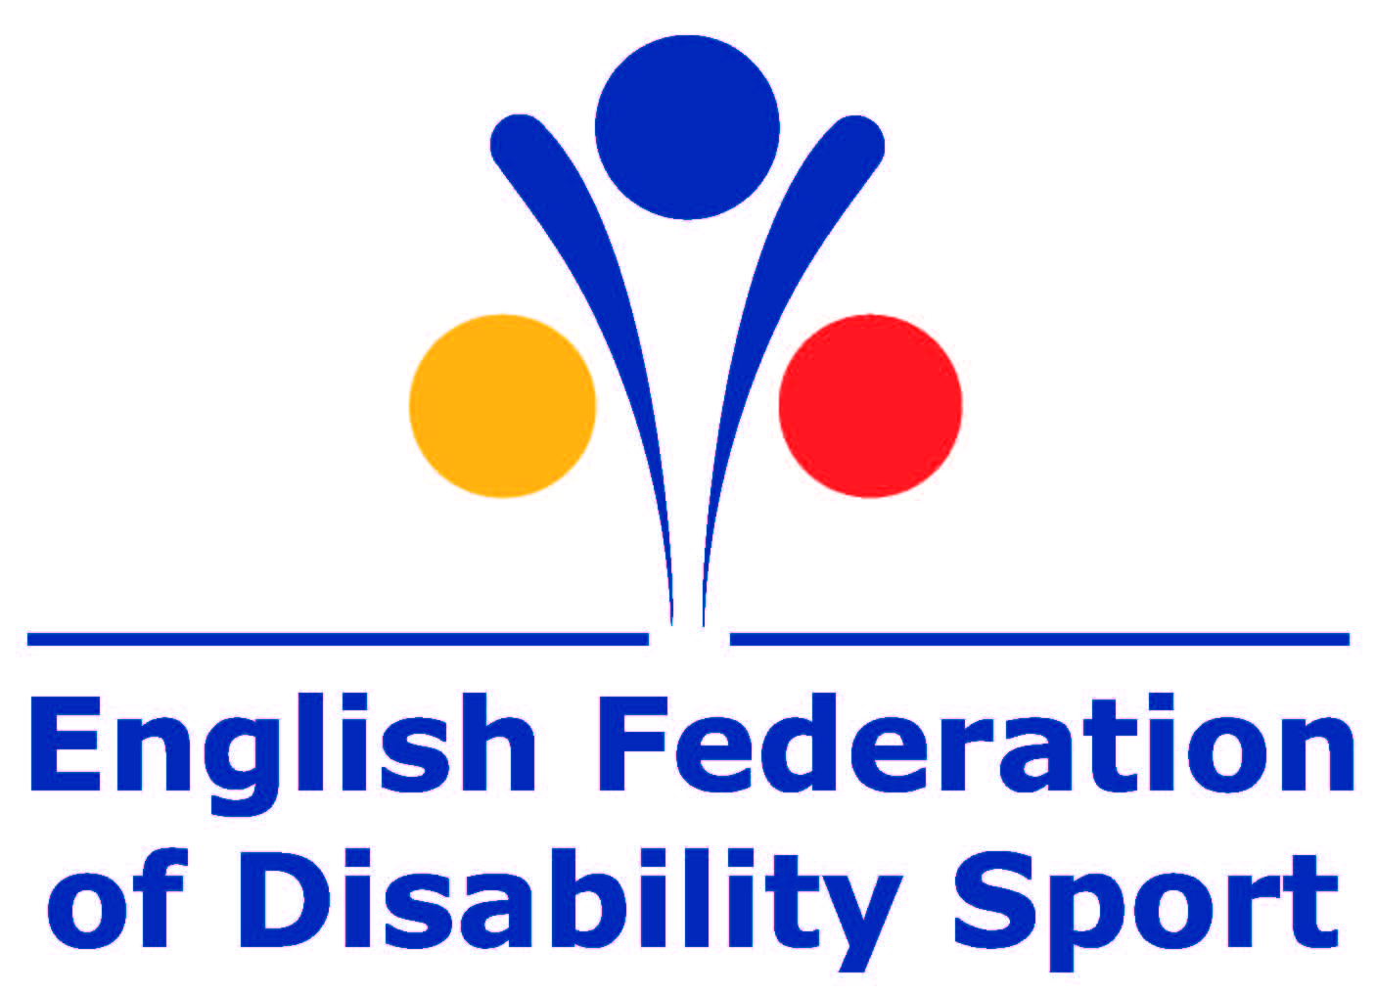

Talk to me:
Understanding how to increase participation in sport and physical activity amongst disabled people in the UK

October 2014
Prepared for the English Federation of Disability Sport by 2CV



Report findings based on market research conducted in May to August 2014 by 2CV on behalf of the English Federation of Disability Sport.

Contents
Foreword 4
Introduction 5
Research Objectives 6
Methodology and sample 7
Executive summary 9
Ten key principles to help providers improve their offers for disabled people 10
Principle 1: Driving awareness - use the channels I already trust 10
Principle 2: Driving awareness – stay local to me 14
Principle 3: Engage the audience– don’t lead with my impairment or health condition 15
Principle 4: Engage the audience- talk to as many of my values as possible 16
Principle 5: Engage the audience – continue to fulfil my values in new ways 18
Principle 6: Offer support and reassurance- make me feel I can do it 18
Principle 7: Offer support and reassurance- reassure me I’m going to fit in 19
Principle 8: Offer support and reassurance- make it easy for me to tell you my needs 20
Principle 9: Offer support and reassurance- ensure my first experience is good 22
Principle 10: Offer support and reassurance- encourage me via your existing advocates 23
Appendix: 24
What we learnt from the stakeholders 24
Extent to which disabled people relate to being disabled 29

Foreword
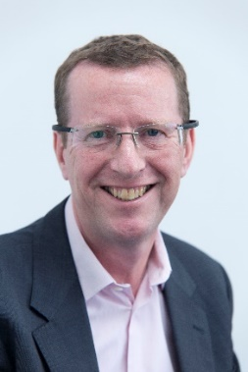
This important new report provides guidelines for sport and fitness providers drawn up with active and inactive disabled people. If applied proactively, I am confident that the principles and approaches set out will mean that disabled people are offered more appealing opportunities that they want to take part in.

Less than half the number of disabled people take part in sport or physical activity for 30 minutes once a week compared to non-disabled people. However, the English Federation of Disability Sport (EFDS) research has shown that 7 in 10 disabled people want to take part in more sport and physical activity. Talk to Me adds to EFDS’s growing research portfolio and builds on the key findings from the Motivate Me report (May 2014).

Whilst many sport and physical activity providers already offer opportunities for disabled people to take part, the low participation level suggests that either disabled people are unaware of opportunities available to them or what they are offered is not appealing enough. This report allows us all to understand how we can make opportunities attractive so that many more disabled people can be active for life.

A key message from the disabled people who took part in the study was “Talk to me, not my impairment”.

Barry Horne
Chief Executive
English Federation of Disability Sport

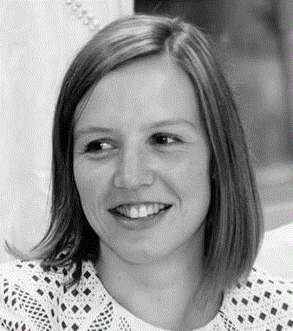
This latest research builds upon our previous work to provide more structured guidance to providers in how to be more appealing to disabled people.

To ensure what is offered to disabled people is right for them, they should be involved in helping to develop what is delivered.

We have worked very hard to produce something which we hope will have significant impact on a practical level for those who are offering opportunities to disabled people.

Emma Spring
Research and Insight Manager
English Federation of Disability Sport

Introduction

Less than half the number of disabled people take part in sport or physical activity for 30 minutes once a week compared to non-disabled people. However, the English Federation of Disability Sport (EFDS) research has shown that 7 in 10 disabled people want to take part in more sport and physical activity.

Whilst many sport and physical activity providers do offer opportunities for disabled people to take part in, the low level of participation suggests that either disabled people are unaware of opportunities available to them or what is available is not appealing enough. More needs be done to understand what changes and improvements can be made to make opportunities more attractive and encourage more disabled people to take part.

This report outlines the findings of a research project designed to better understand how to encourage disabled people to take part in sport or physical activity. It uses a collaborative approach, working with providers and participants, to understand the needs, wants and desires of disabled people in sport and physical activity. Also, how to create activities and communications to be more appealing and attractive.

The report provides 10 key principles for providers to follow. The aim is to improve the opportunities offered to disabled people and make them more interesting. We are currently planning a follow on study that determines whether organisations are successful in increasing participation of disabled people by following these principles.

Research Objectives

The study was designed to build on findings from Motivate Me (EFDS research report released in May 2014). Also, to develop a set of guidelines on how to be more successful in encouraging disabled people to take part in sport and physical activity opportunities.

To generate the guidelines, the study objectives aimed:
- To explore the current needs and attitudes of providers
  - Understand the challenges providers face when trying to offer opportunities for disabled people
  - Identify the information and support that providers need in order to overcome the challenges that they face

- To understand the most effective ways to engage disabled people in sport and physical activity
  - Test previous findings regarding the values disabled people have and the extent to which sport and physical activity becomes attractive if they link to these values

- To understand what type of initiatives are appealing for disabled people
  - Identify the sport and activities disabled people are currently taking part in to understand what motivates them to do so.
  - Explore with participants what elements an ‘ideal’ opportunity would include in order to appeal to them

- To understand what level of reassurance/support is required and how to communicate that
  - Identify what information disabled people need to feel comfortable that a new activity is appropriate for them.
  - Determine the best way to communicate this information

- To understand what channels are likely to generate greatest awareness
  - Identify the key ways in which disabled people would most commonly seek information on new activities. Understand the reasons why these channels work and are trusted more

Methodology and sample

The study ran from May until August 2014 and consisted of two different stages. In total, 88 people took part in the research- a mix of 34 stakeholders and 54 disabled people.

Stage one: Stakeholder summit
A workshop bringing together a mix of stakeholders involved with providing or delivering sport or physical activity to disabled people. The key focus of the workshops was to understand the stakeholders’ needs and strategic considerations when marketing opportunities to disabled people.
11 different organisations were represented at the workshop: British Cycling, Rugby League, British Judo, England Golf, British Rowing, Manchester City Council, Active Cheshire, GreaterSport, England Athletics, Oldham Council.

Stage two: Co creation workshops
Four workshops (two in Manchester and two in London) bringing together disabled people and stakeholders. Participants were encouraged to work together collaboratively in a number of creative tasks to answer the following questions:
    - What do disabled people really want to gain from sport or physical activity?
    - What are the key factors that would encourage them to try different activities?
    - What are the crucial elements that providers need to consider when developing opportunities that will engage and reassure disabled people?
    - What are the key channels that should be used to promote opportunities?

A total of 54 disabled people participated. They were recruited based on the extent to which they felt their impairment impacted on their daily life and their current level of physical activity.
- Group one: Impairment has minimal impact on daily life; currently not active / low levels of activity
- Group two: Impairment has significant impact on daily life; currently very active
- Group three: Impairment has minimal impact on daily life; currently very active
- Group four: Impairment has significant impact on daily life, currently not active / low levels of activity

The four groups all contained a good range of ages, gender, ethnicity and impairments.

There were 6-8 stakeholders present at each workshop. Across the four workshops, stakeholders represented the following organisations: AccessSport, Manchester City Football Club, Oldham City Council, Wigan Sports and Leisure Trust, Gateshead Council, British Cycling, British Gymnastics, England Golf, GreaterSport, Tennis Foundation, YMCA / Instructabiltiy, Sport England, Interactive, Greater London Authority, DisabilitySportsCoach, England Athletics, Action on Disability

Executive summary

This report provides ten key principles sport and physical activity providers can follow to improve their offer to disabled people and make it more appealing.

The principles are grouped into three categories, representing three steps providers need to take to improve their offer. Using feedback from disabled people, the principles offer guidance of ways in which providers can adapt, develop and improve their offer to make them more suitable and appealing.

Figure 1: The three steps providers should follow
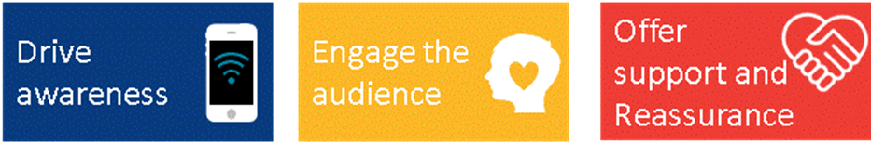

Step one: Drive awareness
Principle one: Use the channels I already trust
Principle two: Stay local to me

Step two: Engage the audience
Principle three: Don’t lead with my impairment or health condition
Principle four: Talk to as many of my values as possible
Principle five: Continue to fulfil my values in new ways

Step three: Offer support and reassurance
Principle six: Reassure me I’m going to fit in
Principle seven: Make me feel I can do it
Principle eight: Make it easy for me to tell you my needs
Principle nine: Ensure my first experience is good
Principle ten: Encourage me via existing advocates

The report goes through each principle in detail, providing evidence of what disabled people are looking for and recommendations of how to meet expectations.

Ten key principles to help providers improve their offers for disabled people

Principle 1: Driving awareness - use the channels I already trust

One of the main questions stakeholders ask is ‘what channels of communication should I use to reach disabled people?’ They want to know the quickest and most effective way to reach the widest number of people.

One answer is to make connections with the disability sector. The disability sector contains organisations which represent disabled people, which disabled people connect with and trust. By forming relationships with organisations in this sector, it gives more direct access to disabled people. If these organisations promote sport and physical activity opportunities, disabled people may be more likely to consider the activity as it is coming from more familiar and trusted source.

From EFDS’s guide to inclusive and accessible communications:
“The way in which disabled people access your communications may be different to non-disabled people; and people with different impairments have different needs or experience different ‘barriers’ to accessing your information. There are approximately 11 million disabled people in the UK – as a group, disabled people are a large part of your potential audience. And, as with any other large group, there can be no one-size fits all approach to how or what you communicate with disabled people.”

Whilst linking with disability organisations can be successful in increasing awareness among disabled people, providers need to be aware that this is not the only or perfect solution, as not all disabled people associate with or connect with disability organisations.

Some disabled people do actively use and engage with disability organisations and trust the advice they provide. However, a large proportion of disabled people do not feel that they have any connection to any disability organisations. Within the study, it highlighted that these are people do not necessarily relate to being a disabled person. They are less to identify with being a disabled person so are unlikely to look for a disability group to support them.

“Sure, I’m disabled but I’m not going to make a song and dance about it. I feel just as able as the guy with 2 eyes. We just see the world differently.” Graham

“I went to the MS group and it was so depressing. I haven’t been back since” Maria

How to meet expectations
Therefore, an over reliance on links with the disability sector could result in a significant proportion of the target audience being unaware of what is potentially available to them. It is important therefore to use a variety of channels of communication. These should include:

Word of mouth from friends and family
Word of mouth is a powerful marketing tool. If a friend or family member recommends something to you it can be very influential. They are a trusted source who knows your likes, dislikes and limitations. They can assess an activity and decide whether it would be suitable.

Previous EFDS research has shown that disabled people have an increased reliance on family and friends. They place a higher level of trust in their views and opinions. Therefore encouraging friends and family to be advocates for new activities and initiates for disabled people could be very influential. It can raise awareness among disabled people and encourage them to take part.

Health care professionals (such as GPs, consultants or physiotherapists)
Encouraging health care professionals to promote your sport and activity in their waiting rooms, clinics and one-to-one consultations can be a positive step. Health care professionals, especially people such as physiotherapists, often have strong trusting relationships with disabled people. If they advocate activity it may be more influential.

“It was in my doctor’s surgery that I first saw the leaflet for adapted sports- I spoke to him about it there and then and from there I tried to find out as much as possible” Fashat

Internet search engines
Internet searches are an extremely common way disabled people seek information on sport or physical activity. However, to ensure people can find your activity, it is important to maximise your Search Engine Optimisation (SEO). There are many guides available on this, but it involves improving your website’s content links to ensure people can find you more easily when they search for activities.

You must consider the user’s journey to and on your website too. Your website may be found through various searches, but is its content accessible to everyone? Take a look at our inclusive communications guide which will give you a checklist for your website.
Did you know that making your website more accessible can improve your SEO too?
http://www.efds.co.uk/resources/case_studies/2697_access_for_all_efds_inclusive_communications_guide

Social media (Facebook, Twitter)
Social media is a popular way to find about and share information about activities. Make sure you have a social media presence and use it regularly. Utilise their capacity for pictures and video, considering their accessibility too. This gives people with a visual representation of what you have on offer. It allows them to make a more rounded judgement of whether your activity will be suitable for them.

“I’m always on Twitter and Facebook. Different companies and organisations often post lots of videos of events and different classes which can be so useful for you to see if you think it might be worth it.” Claire

Warning: Do not heavily rely on the use of web based information alone to promote your activity. Whilst this is a convenient and cost effective way to share information, only 60 percent of disabled people can access the Internet at home compared to 86 percent of non-disabled people who can. Research shows that some people with certain impairments (e.g. Intellectual impairment) as well as younger and older age groups are less likely to use social media. Therefore to maximise exposure, it should be used in conjunction with other promotional channels and a suite of communications.

Leaflets or flyers through the door
Direct mail can bring the information right to disabled people. It can be costly so it is important to know more about your audience and produce it in the most accessible ways. This can involve your design, typeface, language and alternative formats. Our inclusive communications guide has a number of tips.
http://www.efds.co.uk/assets/0000/9149/EFDS_Inclusive_comms_guide_accessible_PDF_APRIL_2014_FINAL.pdf

In addition, to any text that you use, also consider using visuals (with alternative descriptions for those who cannot see the imagery) of the actual activity and facility. Our research shows that people are keen to see the actual activity with real participants, to help them get a sense of whether or not they would fit in.

Always provide many contact points as well, whether it be a web page address, email address or telephone number. Providing people with additional contact options means they have an opportunity to ask questions before they arrive to determine whether it will be suitable for them. Offering a range of contact options makes you more accessible as well. It means that people with different needs can choose the option which is easiest for them.

Posters in the ‘usual places’
As with leaflets, think about using realistic visuals and providing numerous contact details.

When choosing where to put posters, the ‘usual places’ refer to places that disabled people visit in their everyday life. These are places like schools, libraries, local takeaways, shopping centres or health centres.

Again, it is best not to rely on just a poster to promote your activity. Posters are most effective when used within a range of communications, so people who do not or cannot see your posters are not restricted in finding out about your opportunities.

Demonstrations
Demonstrations of your activity and involving those who take part can be very influential. Putting on these demonstrations in the ‘usual’ places’ suggested above means that you can capture people going about their everyday business who may never have considered sport, but may be interested if they see a demonstration.

If you cannot demonstrate the actual sport in these usual places (it might be water based or require certain equipment), you could consider a stand in these places instead with images of the sport. Bring along members of the team or club. This gives people a chance to see what the activity is and speak to people who currently take part to ask any questions to reduce any concerns they may have

“It was chatting to a few people from the disabled football organisation standing outside of the supermarket that first pulled me in. We had a really informal chat about it. I told them my worries and they were able to reassure me there and then. I’d only been out to grab some dinner and ended up signing up!” Mark

Local newspapers or magazines
This communication channel is a good local way of promoting what is available. This may be through articles, covering your activities, or perhaps adverts to promote what you have to offer.

Depending on the size of the advert or article you should include photos of the activity and venue. This gives people more information about the type of setting and the other people who attend. As with the advice on leaflets above, you should also include additional contact information. Be open to people to get in touch with any questions they may have.

Principle 2: Driving awareness – stay local to me

Travelling can be more of a challenge for disabled people. They are often reliant on the support of other people or the use of public transport. Depending on the person’s impairment, some people may be unable to spend a long time sitting down and driving.

Those who are serious about their sport or activity are more willing to travel, but still find travel can be difficult due to a lack of availability or find it too expensive.

Therefore, activities outside of their local area can be dismissed as they become too difficult to attend. This can be an even bigger barrier when a person’s motivation to participate is already limited. Participation can become harder to make into ‘a habit’ if the travel is so taxing.

How to meet expectations
To make participation feel easier, activities will be more successful if they are on their doorstep and communicated locally. Activities on a local level mean that they will be more likely to consider going as ‘getting there’ is less of a barrier

“There’s already so many struggles with taking part in sports already without having to worry about getting there. I need something local to me, somewhere I know I can get too easily and not have to worry.” Elizabeth

Activities should be locations that are physically local such as:
- The local park and green spaces
- The local leisure centre
- School and community centres
- Local shop parade or shopping centres

Think about the physically local places to be seen, as well as being ‘digitally local’:
- Link into local blogs
- Have localised Facebook pages or Twitter feeds
- Be involved in and create local online forums

Principle 3: Engage the audience– don’t lead with my impairment or health condition

Leading communications with images and words which talk explicitly about a person’s impairment can often fail to inspire or motivate disabled people. It was found that they do not necessarily appeal or make disabled people want to participate- even for those who relate to the term “disabled person”.

Communication that focuses on these messages is quickly filtered out as ‘not for me’ and perceived as only relevant for a narrowly defined audience. For example, when the term “disabled” is used, it is typically associated with profound physically impaired people rather than all types of impairment.

“When I read something like that, for me it’s just talking to wheelchair users.” Jane

How to meet expectations
Marketing and communications need to look beyond the participant’s impairment to appeal and motivate a greater proportion of this audience.

Think about what your sport or activity offers above and beyond being suitable for disabled people.

Example: Wheelchair rugby
Promoting the training sessions as something which offers an upper body workout you cannot get anywhere else.

Example: Virgin active health clubs
Promotional posters for the health clubs using the tag line ‘whether you love swimming or just being naked’. A more humorous approach to attract attention.

Principle 4: Engage the audience- talk to as many of my values as possible

To make an activity or programme more attractive or appealing it must link to the things that disabled people value in life. These are the things they find important, which motivate them every day.

Our research has identified six categories that the values of disabled people can fall into. :
- Friendships and connections
- My health
- Progressing in life
- Mental strength and well being
- Having fun and feeling free
- Family and support system

Figure 2: Six values
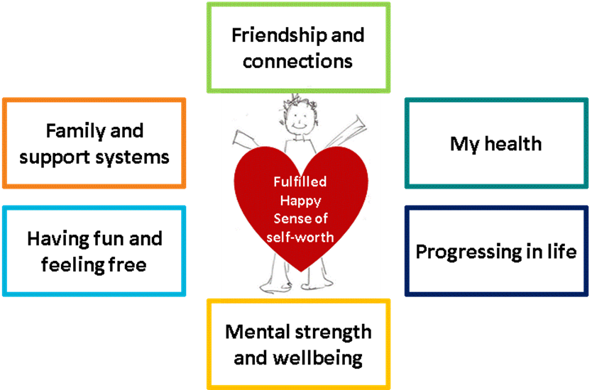

Sport and physical activity can help people achieve these values in different ways. To make sport or activity more appealing, they would be more effective if you aim to speak to as many values as possible.

How to meet expectations
Speak to some of the people already taking part to find out why they first came along and what they enjoy about the activity that makes them return. This will help you understand what values your activity appeals to. This in turn can help you think about promoting the activity in a different way.

The people we spoke to who are currently active identified a number of ways in which taking part in s port or physical activity helped to tap in to their everyday values. .

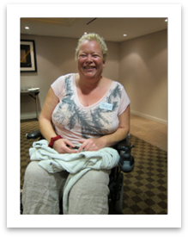
Paula
Paula takes part in Strictly Dancing – a wheelchair dance group
She went from dancing at nightclubs with friends to joining a dance club and competing. She goes dancing because:
- She loves disco music
- It’s a really social experience
- She has loads of fun doing
- It’s good for her health

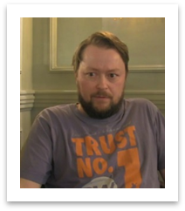
Graham
Graham plays 5- aside with his friends once a week. He plays because:
- It is social and friendly
- It finishes up with a drink in the pub afterwards
- The team are part of a league and he likes competing

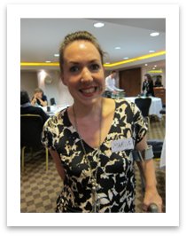
Maria
Maria is a member of a rowing club. She likes rowing because:
- She loves competing
- She enjoys the feeling of freedom she gets from being on the water, in all weathers
- She likes the movement of the boat
- She enjoys the camaraderie of her teammates

Principle 5: Engage the audience – continue to fulfil my values in new ways
For those who are already active, the values that sport or physical activity appeal to may change over time. Providers may need to change and adapt offers so that different values are met to encourage continued participation. Whilst the activity itself can link to values, allowing people to compete, socialise, improve their skills or take part with family and friends, equally may stretch beyond the activity.

How to meet expectations
There may be opportunities to take an active role in the club such as club secretary or supporting new starters. Disabled people may be interested in becoming an instructor or trainer. They may have personal skills, which they can use to help and support the group or team, such as social media promoter or social activity coordinator.

“For me the sport has gone way beyond playing football. I’m now really active in encouraging new members into the local deaf team playing 7-a-side football every week.” Henry

Principle 6: Offer support and reassurance- make me feel I can do it

Our research found that one of the barriers to participation is that disabled people fear that they are good enough to take part. Some believe that the ability levels of people already taking part will be above and beyond what they are capable of.

Disabled people want to know that sport or activity is within their capability. Trying something for the first time can be an uncomfortable experience for most people. This can be even more prominent among disabled people as they are generally more aware that their ability to take part may be more constrained.

This can lead to them being less likely to consider a sport or activity if they feel it is outside their perceived ability.

“I don’t like going to disabled-only classes, but when thinking about going with people without impairments, I think I’m not going to be able to keep up with everybody else. Sometimes I know I’m being silly but it really puts me off. I don’t want to be singled out but I want other people to make me feel welcome regardless of my ability.” Angela

How to meet expectations
To overcome these concerns it is important to help disabled people understand the ability levels required for the activity. Do you provide an activity for elite level people, which requires lots of past experience and ability? Is the focus on competition and progression? Or does your offer allow differing levels of ability, from beginners to elite? How do you ensure that there is something for everyone?

It is important to use the right language and messages to convey the level of ability. Many people find language like “trial” more appealing. You may be more successful if you use words which suggest it is the first rung on the ability-ladder, like:
- Try
- Have a go
- Beginners welcome
- First timers
- Taster sessions

What is also appealing are references to ability limitations without explicitly stating anything about disability:
- Zumba Gold
- Limited movement
- Low impact

In addition to this language, disabled people like to know that if they turn up and take part they can. There should be enough information available to them which suggests a guarantee of participation. For example, ‘we have a wide variety of adaptive equipment’ or ‘we’ll guarantee we’ll get you on to a bike’.

“The first thing I saw on the ad was ‘we will get you on a bike no matter what’. That just made me think ‘right, if they’re saying they can let’s see how serious they are’, and I’m still there today!” Trevor

Principle 7: Offer support and reassurance- reassure me I’m going to fit in

The fear of standing out and being different from others is a fear for a lot of people. It can be even greater for disabled people who are discriminated against regularly because of their impairment. The fear of standing out or being considered different can be more restrictive for some disabled people.

When considering participating in new activities, a strong, influencing factor is a desire to fit in. It influences what they will and will not consider.

“I used to be so much more confident and that’s what I miss the most. I need to have someone that will encourage me in the right way and push me enough for me to shake the fear I have every time I step into a class.” Maria

“I want the other people there to be rubbish at it”. Marie

How to meet expectations
To help people overcome the fear of standing out consider:

The imagery you use
Feature images of people of different ages, sizes and abilities. People want to see ‘real people’, people ‘like them’ that they can relate to. Show images of the actual group and session and the people who take part. This gives potential participants a better idea of the people they will be mixing with.

Try and avoid using images of sports men and women who look elite for grassroots activities. This could be people who look super fit, kitted out entirely in branded sportswear, being active without breaking a sweat. Although elite sportsmen and women help at an overall aspirational level, they are less effective in direct communications as they are harder to identify and relate to.

Make the experience more tangible
Use video and photos of your activity to show a potential audience what the experience will be like and who will be there. Provide case studies of people already involved in the activity and regularly participate. Show the journey they have made.

“I think being able to see it in action as well, and see different types of people taking part so you feel more comfortable.” Maria

Principle 8: Offer support and reassurance- make it easy for me to tell you my needs

Our research has shown that disabled people feel that if instructors were aware of their potential activity limitations because of their impairment, they would feel more comfortable about taking part. If the instructor is made aware of their needs they are able to work around them. This means that the participants are more likely to try a session which is adapted to be more suited to their needs and therefore more fulfilling.

“The one great thing that keeps me coming back is that my trainer knows my limitations but is creative in how he approaches my training and participation. He’ll revise some of the more difficult activities to make the session work for me, but without losing the competitive side of things that I love so much.” Maria

However, disabled people can be reluctant to share their limitations. This is due to past experiences where they have declared their limitations only to be excluded from activity. People fear sharing their needs in case they are prevented from taking part.

Also, if asked to share their needs and limitations publicly in a sessions, this can be embarrassing. As previously covered, disabled people just want to blend in. Publicly declaring their limitations makes them stand out. So often, instead, they may say nothing, meaning the instructor will not know and their session is less fulfilling.

How to meet expectations
It is therefore important that there is a process that participants can use to share with instructors their specific needs without people being singled out. People need to be reassured, that by declaring their needs it will improved their overall experience rather than lead to them being excluded.

New participants should be encouraged to share any specific needs ahead of the session. This could be done in a face to face chat with the instructor 5-10 minutes before taking part. It should be something all new participants go through so people do not feel singled out, to find out their experience, expectations and any limitations on being able to take part. Alternatively, there could be a process where people can telephone or email the instructor prior to the session to ask questions and provide some background about themselves. Or another option is to provide forms for everyone to complete when they first attend an activity, to capture information about them that instructors can read so they are aware of the needs of the group. These should be made accessible for everyone and is a great time to ask what communication preferences they may have to for further marketing.

This gives participants a chance to openly discuss their concerns with someone who understands and can advise on participation in the session. Instructors are more prepared to offer a quality sessions and participants will be more confident that they will receive something suitable for them to enjoy.

Principle 9: Offer support and reassurance- ensure my first experience is good

The instructor, support staff and other participants all play a significant role in a new participant’s first experience of an activity. It is not just what people experience whilst taking part, but also before and after they have attended an activity.

How to meet expectations
Think about the whole experience for a person, which starts from when they arrive. Ensure that from arrival through to the session, all staff who interact with participants are equally welcoming and helpful. Focus on quality customer service by all the workforce, not just the instructor.

Before:
Be friendly and open and encourage people to come and join in your activity. Send a welcoming accessible email to anyone who has contacted you and shown and interest. Consider a ‘thinking of joining/ new participant’ page on your website which provides information of the demographic of current participants, what to expect from a session, what to bring with them and what is included.

Plan any session to allow for a range of abilities. Think about how activities can be adapted to suit different needs.

During:
Include an official welcome and introduction for any new participants. Introduce them to staff and the rest of the group. Involve other participants in making them feel welcome- maybe using some kind of buddy scheme, or group warm up games.

“The teacher is obviously one of the most important factors in making you feel safe and supported. I’ve experienced some pretty poor coaches in the past who were just a bit eager to please those more able in the group, so I always felt like the slow one at the back. It really knocked my confidence.” Daniel

After:
Once someone has attended an activity, try and maintain contact. Make a follow up phone call or email after the session to check in with them and ask for any feedback they might have. Involve these new participants in any new activity development. They could support your growth and provide new ideas.

Principle 10: Offer support and reassurance- encourage me via your existing advocates

People who are already taking part in your activity and enjoying it are the best advocates for others. They take part in the activity because it fulfils some of their values. When they talk about their involvement they are often very enthusiastic and convincing.

They have made the journey for themselves, from being a new person, to someone who really enjoys taking part. They can therefore can relate to others about to embark on that journey. They know how it feels and what people need to hear to help them along.

How to meet expectations
Ways in which to utilise their skills:
Trainers | Buddy system | Open days/ event days-
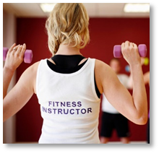 | 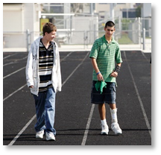 | 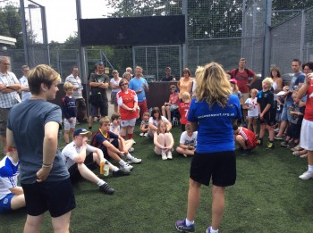
Existing advocates to become trainers and instructors | Assign new members to existing members to look out for and offer support if needed | Current participants attend and demonstrate their enthusiasm and be available to answer questions new members might ask

Appendix:

What we learnt from the stakeholders

The stakeholder workshop offered a platform for stakeholders to discuss their past, current or future plans and experiences of delivering opportunities for disabled people. The discussions identified areas of success as well as areas where stakeholders would benefit from further support and guidance.

Successes
The stakeholders were able to identify a number of areas where they have experienced successful delivery.

The commonality between these successful experiences seemed to be linked to different forms of partnerships.

- Strategy and delivery : joint decision making (co production)
Greater success rates is experienced when strategic decisions are made in partnership with the people involved with the delivery of programmes. By including these people in strategy and long term planning, they can provide an additional perspective on what can be successfully achieved.

The deliverers interact with disabled people who are taking part, and therefore have a greater level of knowledge and understanding of the audience needs. They also realise the practicality of implementing new initiatives or ideas.

- Include disabled people
Work with the disabled people who are interested in what you have to offer and ask them how to improve it and make it more appealing. Use their input to design your offer. You could create user groups to test future ideas and communications.

To ensure that participants, coaches or leaders feel fully comfortable with taking part in any session, build in time before a session or initiative to allow for an informal, preliminary meeting. This allows the instructor to familiarise themselves with the needs of the participants and to tailor the activity accordingly. It also provides participants a confidential time to share their concerns and expectations, reassuring them that they will be supported and looked after.

When providing training to coaches or leaders on including disabled people in their sessions, include both staff and disabled participants. This encourages a mutual understanding of needs.

- Cross sector working
Working with partners outside of the sport and physical activity sector provides additional knowledge and insight into disabled people’s aspirations and challenges. It brings together different organisations with different knowledge and skill sets that complement each other, enabling them to provide a more rounded and enjoyable experience for participants.

In order to increase exposure of their provision to disabled people, the sport and physical activity sector should think about partnerships with the disability sector and the health and social care sector.

- Prioritise partnerships
Whilst partnership working does provide many benefits, it is important to prioritise who to build relationships with. Choosing a smaller number of key organisations will mean resources can be focused and should result in a greater quality of relationship, level of understanding and leads to better outcomes.

The providers need to understand what kind of support and guidance they seek, and then identify suitable partners who can provide this. For example, when deciding which rowing clubs to provide more funds to in order to increase provision for disabled people, British Rowing have a set criteria. They rate potential partners on the equipment they already have available, the volunteers they have within their club to support new members and open-mindedness of the deliverer to adapt and change their practices to be more inviting.

Challenges
The stakeholders identified a number of challenges.

- Budgets
Budgets for provision of sport and physical activities are always limited. When providing opportunities for disabled people there is often an additional requirement for budgets due to the need for additional staff training or an increase in staff numbers in the actual activity.

It can be challenging for providers to find the additional funds to cover these resources and can lead to activities not being run.

- Reliance on volunteer coaches
To run initiatives, stakeholders are often heavily reliant on volunteer coaches. These coaches can often focus on performance or elite sport in their work, looking to improve people’s abilities and move them on to bigger and better things. When trying to encourage people to consider taking part for the first time, this performance focus could be rather off-putting.

For some, performance and working toward elite level capabilities may come later. This may come after they have tried the sport or activity and realise that they have skills. However for the majority, their first and ongoing experiences need to be enjoyable and fun, which requires a different mind-set from coaches and leaders.

Providers therefore face a challenge in developing a volunteer workforce with multiple skillsets, or encouraging volunteers to learn new skills without asking too much of them and losing hem as volunteers.

- Lack of inclusion training
There is a perception among providers that there is a lack of relevant or suitable ‘inclusion training’ that will provide them, their staff and volunteers with the necessary skills and confidence to support disabled people to take part in their activity. This results in providers feeling that their staff often lack an understanding of how to effectively run sessions with different disabled people.

There is already a great deal of information and support available for training people in providing sport for disabled people. However, awareness of where to go and look to find the training is limited. Also, current training may not answer the needs of all providers. Work needs to be done to better understand the type of information and support providers would like from training, so it can be updated and adapted to make it more suitable for use.

- Unclear of who their ‘disabled audience’ is
Stakeholders often admit to having a poor understanding as to who their ‘disabled audience’ actually is. They often end up trying to communicate to disabled ‘stereotypes’.
“Everybody wants an amputee to use on communications or PR” Stakeholder
Many stakeholders feel that physical impairments gain more recognition and monetary support than people with ‘hidden’ impairments. This can come down to the level of understanding of the definition of disability and who that includes.

In the social model of disability, all people whose daily life is affected by long term illness or disability is included. This is a vast range of people, including those who have health conditions such as cancer, asthma or diabetes, to people who have hearing loss, to people with congenital conditions such as Spina Bifida.

Stakeholders need to spend time in understanding who their ‘disabled audience’ is. Are there specific groups of people with certain impairments or health conditions who are more suitable for the activity, and should efforts be focused here. If you want to appeal to as many people as possible, you need to consider imagery and language used. This ensures that all people resonate with what is used e.g. do not use a wheelchair user and expect all disabled people to want to take part in what you are offering. You need to expand your communications suite and have a range of imagery.

- Lack of knowledge of what to provide and how to promote it
Stakeholders felt they lacked knowledge on how to create engaging and relevant communications or initiatives that will appeal to disabled audiences. They also claimed to struggle to understand the most effective communication channels to use to reach the audience.

There is a wealth of free resources available to providers to increase their awareness and understanding. This includes a number of EFDS resources
- Inclusive communications guide: Advice on how to reach more people through inclusive and accessible communications
- Opening doors: a guide to improve physical access in sports clubs
- Research – a variety of research to show what disabled people seek from sport and activity (including this report)
- Engagement guide- a guide to improve local reach and relationships with disabled people

- Unaware of disabled participants
When running initiatives, challenges can arise when participants do not declare themselves as ‘disabled’. This can mean instructors find it hard to plan and provide effectively for disabled people who may join.

Previous research conducted by EFDS showed that one of the main things providers need to ensure is that disabled people are effectively supported when taking part in sport. To ensure that they are able to do this, providers need to know the support needs for individuals, usually based on restrictions or limitations that they face through their impairment.

This research showed that participants can be restrained in telling providers that they have impairments or health conditions, as previous experience suggests this most often leads to exclusion from activities rather than inclusion. Providers need to find a way to collect relevant information from participants, to ensure they can provide a quality and safe experience, without making the individuals feel uncomfortable about sharing the information.

Extent to which disabled people relate to being disabled

The research showed that disabled people sit on a spectrum regarding the extent to which they relate to being disabled. People range complete relating to being disabled to not relating at all.

Figure 3: Degree to which respondents relate to the term “disabled person”

The disabled people in the study, who related more to being called a “disabled person” generally identify to the term as part of their lives. Generally, people with congenital impairments, (those who are born with the impairment) are more likely to relate to the term and are at one end of the spectrum.

“I've been like this all my life – I didn’t even know I was disabled until I was about 12. If people don’t like it, they don’t have to look at me.” Elizabeth

Disabled people who are less comfortable with their impairment don’t really like or accept their impairment as part of who they are. They can struggle to cope with it and often live in denial. They may try to hide it from other people who they are not familiar with and ma y actively avoid situations which emphasises their impairment.

People who did not relate to the term “disabled person” were more likely to be those who had acquired their impairment through illness or injury. In such situations, the respondents often made comparison to ‘how they used to be’.

“Because my friends and family know me, I don’t feel embarrassed at all- it’s when I’m out in public when I have to speak to people I don’t know- it can make me so nervous.” Alan

“I don’t really like to tell people about my hearing – I try to get by.” Jane

“It’s the staring- I feel like people would be looking at me all the time and that makes me embarrassed.” Maria

For more information on this survey or report, please contact Emma Spring at EFDS.
Email espring@efds.co.uk or telephone 0161 2005442
The report is available to download on www.efds.co.uk
Twitter @EFDSInsight

Join our insight panel
EFDS is always looking for disabled people’s support on our insight projects. There are many occasions we may get asked to help with other organisations’ research or for our own development plans.
If you would like to join our panel of disabled people, please contact us on research@efds.co.uk or 0161 200 5442. It will be mainly communication via email or telephone, so you do not have to commit to any unnecessary time or travel.

18% of disabled people take part in sport once a week for 30 minutes compared to 39% of non-disabled people, Active People Survey, June 2014
Disabled people’s Lifestyle Survey, EFDS, 2013
Motivate Me, EFDS, May 2014
Fulfilling Potential, 2012
Based on feedback in this research, these six values have been updated from the values listed in the Motivate Me report released in May 2014
Motivate Me, EFDS. May 2014

