Typhoo National Junior Athletics Championships 2018
Entry pack

Venue: Coventry Athletics Track
Gibbet Hill Road
Coventry
CV4 7AL

Date: 7-8 July 2018

Competitors weekend entry fee (including lunch, programme and t-shirt): £35

Competitor entry fee u12s (including lunch, programme and t-shirt): £15

Saturday Night Gala Dinner Fee (non-residents at the event hotel): £30

Additional packed lunches available for 2 days: £12

Entry Fees are payable to: Activity Alliance, this can be done by BACs, Cheque or Paypal, invoices are available on request.

Closing date for entries: 18 June 2018 No late entries will be accepted unless agreed with the events department

Completed forms and payment should be sent to:
Activity Alliance, Suite 4SA Trafford House, Chester Road, Stretford, M32 0RE
jannine@activityalliance.org.uk

If you need to discuss any of the enclosed please do not hesitate to contact the office. Please ensure you complete ALL relevant sections of this entry pack.

Entry information
The Championships will be run under the Activity Alliance Profile System. Further information on the Profile System can be found via the Profiling Toolkit on the Activity Alliance website.

Age Groupings
- Under 12 – competitors must be 9-11 years old at midnight on 31st August 2018
- Under 14 – competitors must be 12 or 13 years old at midnight on 31st August 2018
- Under 16 – competitors must be 14 or 15 years old at midnight on 31st August 2018
- Under 18 – competitors must be 16 or 17 years old at midnight on 31st August 2018
- Under 20 – competitors must be 18 or 19 years old at midnight on 31st August 2018

Competition Timings
The exact schedule of events will be generated once we have received the entries, however, the approximate timings of the weekend will be as follows:

Saturday 7 July 2018
9.45am – 5.30pm
Sunday 8 July 2018
9.30am – 2.00pm

Event Hotel - Chesford Grange, Kenilworth, Nr Warwick CV8 2LD
Accommodation can be booked directly with the Chesford Grange, Kenilworth. Please send your requirements by email to chesfordreservations@qhotels.co.uk with the reference ‘Activity Alliance’

Accommodation is available at £159 per person, weekend package rate (two nights, dinner bed and breakfast) in a twin/double room or £199 in a single room. Please be advised that rooms are booked direct with the hotel and payable to the Chesford Grange. The price includes the gala dinner on the Saturday night.

Registration
There will be a Team Managers Meeting at 7.30pm on Friday 6 July 2018 at the Chesford Grange and all athletes must be registered prior to the meeting if they are staying onsite at the event hotel.

Teams/individual athletes may register on the morning of the competition if they are not staying at the event hotel, however please note that the final start sheets for the event will be printed immediately after the Team Managers Meeting and no amendments or additions will be accepted on the day of competition.

Refunds
If a competitor/escort withdraws from the event more than two weeks before the Championships, a full refund of the entry fee will be given, on the provision that Activity Alliance incurs no costs i.e. does not have to pay for the catering being cancelled. If a competitor/ escort withdraws less than two weeks before the Championships NO refund will be given. All withdrawals should be notified to the Events Team as soon as possible, and should then be confirmed in writing.

Guesting in events
Competitors may guest in events (take part in more than 3). However they will have to have met the qualifying standard in all events and this will have to be agreed with the Activity Alliance National Events Manager. Points and medals will not be awarded to guests.

Participant Information
Please note that there is a group entry form available if you are entering more than one athlete
First Name |  | Surname
Date of Birth |  | Age
Male/Female |  | Tel.no
Address
Region/Country
Email
Athletics Club (if any): |  |  | CP Sport membership No.
This event is being delivered in partnership with Cerebral Palsy Sport and will count towards to Cerebral Palsy Sport Series Awards.
Activity Alliance Profile |  | IPC Class
Please fill in both the relevant profile and grouping, if your athlete has an IPC class please use this above an Activity Alliance profile. For guidance on profiling please see the Profiling Toolkit.
Medical Information
Medical Information
Disability (please state)
Please indicate if you have any medical conditions or any other special requirements we should be away of e.g. asthma, epilepsy, allergies:
Type of reaction/ Treatment required:
Current injuries or medical treatment:

Competitors Code of Conduct
We have a responsibility to promote high standards of behaviour in the sport. Competitors and staff will at all times be expected to adhere to the following minimum standard of behaviour and conduct.

- Respect the spirit of fair play
- Take responsibility for my own behaviour
- Respect the rights and dignity of others and never be involved in discrimination of any kind
- Never use inappropriate language or gestures
- Always behave in a considerate way towards fellow participants, officials, profilers, event
organisers and venue/hotel staff
- Protect others from verbal or physical abuse and threatening and intimidating behaviour
- Never take part under the influence of alcohol or drugs
- Not possess any prohibited substances or performance enhancing drugs as set out within the national policies adopted by UK Sport and British Athletics

Activity Alliance reserves the right to withdraw competitors from the event if they do not keep to the contract. We do hope this will not be necessary.
Medical Consent
This must be completed by the parent/guardian of any competitor under the age of eighteen years on the date of the competition.

I ..................................................................being parent/guardian of the named child on this entry form - hereby give permission for the School/Team Manager/Event Manager to give the immediate necessary authority on my behalf for any medical or surgical treatment recommended by competent medical authorities, where it would be contrary to my son/daughter’s interest, in the doctor’s medical opinion, for any delay to be incurred by seeking my personal consent.

Signature of Parent / Guardian ……………………………………………………….

Activity Alliance Safeguarding Procedures
At Activity Alliance we are committed to promoting the safety and welfare of all disabled people involved in sport and ensuring we promote the welfare of all children and young people and their rights to be protected from harm. Please ensure that you have read and understood Activity Alliance Safeguarding policies and procedures. These are available at Safeguarding resources, these will also be promoted prior to and will be available at the event.

General Data Protection Privacy Statement
Activity Alliance take your privacy seriously and we will only use your personal information to provide the services and products that you have requested from us.

We would like to keep in touch with you from time to time about the work we do, our participation opportunities and fundraising appeals.

Please tick to confirm you are happy for Activity Alliance to contact you:

Please tick to say how you would like us to contact you:

Post Email E- Newsletter Telephone Text Message

If you selected email, please let us know of your preferred email address

Please tick to confirm you are NOT happy for Activity Alliance to contact you:

We will never sell your data and we promise to keep your details safe and secure.
You can change your mind at any time by email events@activityalliance.org.uk or clicking the unsubscribe links if you no longer wish to receive our newsletters.

Individual Competitor Declaration
I/We have read and understand the Activity Alliance Safeguarding Policies Yes/No
I I/We agree and sign up to the Activity Alliance code of conduct Yes/No

Signed: _____________________________________________ Dated: ______________________
Contact Details for Pre-Event Information

Please note that it is the responsibility of the athlete representatives to liaise closely with the School Coordinator or Team Manager if there is one to ensure that they are informed and updated in respect of the competition.

Please fill in the following details to receive pre event information if you are a school, club or representing an individual entry.

School/group/
Region:
Contact Name
Contact Address

Telephone:
Email

Safeguarding
We have read and understand the Activity Alliance Safeguarding Policies Yes/No
We have a safeguarding policy in place at our school/club Yes/No
The School/Club has a risk assessment policy when travelling for competitions Yes/No
(Please delete)

Signed: ________________________ Dated: ________________________

Costing and payment
 | Cost | Total | Payment method and reference
Competitors Weekend Entry  (including lunch and t shirt) | @ £35
Gala Dinner (Competitors/Escorts not staying at Chesford Grange) | @ £30
Escort/Helper packed lunches (total cost for the weekend - Sat and Sun) | @ £12
 | TOTAL | £
Entry Fees are payable by the following methods:
Cheque to Activity Alliance

BACs: English Federation of Disability Sport SC 202409 A#. 00246727,

PayPal: federation@efds.co.uk using reference NJAC and name of athlete or school/group

Invoices are available on request to jmassie@activityalliance.org.uk Please note entries will not be accepted without accompanying payment if an invoice has not been requested.
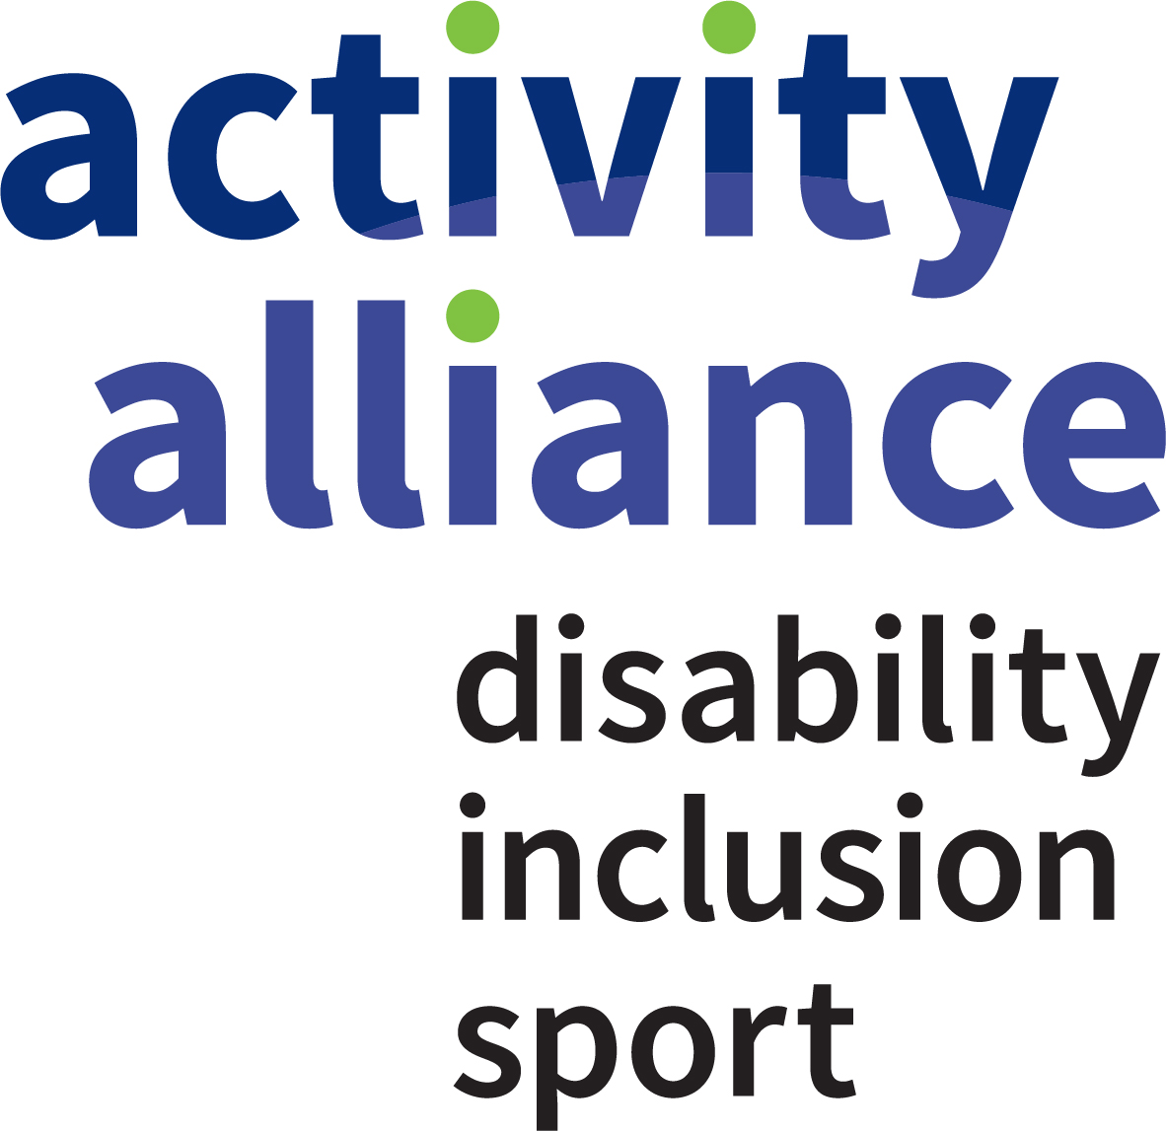

Entry information

Please note that there is a group entry form available.

First Name |  |  | Surname
Date of Birth |  |  | Sex |  | Male/Female
Age Group |  |  | T-Shirt Size (S,M,L,XL)
Region/Country
Athletics Club (if any): |  |  |  | CP Sport membership No.
Activity Alliance Profile |  |  |  | IPC Class
Please fill in both the relevant profile and grouping, if your athlete has an IPC class please use this above an Activity Alliance profile. For guidance on profiling please see the Profiling Toolkit.

Events
Event 1 | Event 2 | Event 3 | Comment
For information on available events please see the ‘Event Info and National Standards Booklet’
T11/12 or P37 competitors should indicate if they compete with a caller/guide.

Guesting in events
Competitors may guest in events (take part in more than 3). However they will have to have met the qualifying standard in all events and this will have to be agreed with the Activity Alliance National Events Manager. Points and medals will not be awarded to guests.

Photograph/Film Footage/ Social Media Consent

It is intended that we will have an official photographer and Social Media Officers at the Typhoo National Junior Athletics Championships.

In accordance with our safeguarding policies we will not permit photographs, video or other images of a participant being taken or shared without the consent of the participant and the parents/carers of a participant under the age of 18.

From time to time we may also allow use of photographic images and videos by third parties. These third parties will only be those with an official association with Activity Alliance.

Activity Alliance will take all steps to ensure these images are used solely for the purposes they are intended. If you become aware that these images are being used inappropriately you should inform Activity Alliance immediately.

Please complete the form below, selecting that you do or do not give your consent, to enable us to use these images to actively promote the work of Activity Alliance.

Please sign the following statement.

I hereby grant/do not grant (delete applicable) Activity Alliance the absolute right to use the images resulting from this photo/film shoot. This includes any reproductions or adaptations of the images for all general publicity purposes, in print, on our website or social media sites, such as twitter, Instagram and facebook.

Name of participant:
Signature of participant:
Signature of Parent / Guardian:
(if under the age of 18)
Date:

Activity Alliance Evaluation Survey

At the Typhoo National Junior Athletics Championships, we will be carrying out an evaluation survey with participants, parents, coaches and volunteers. Findings will be used for research and monitoring purposes; that is, to measure and demonstrate the impact of the event, to improve the event experience offered to all attendees and to encourage people to attend in future.

We will not ask for details in the survey that identify any attendees and any unintentionally provided will be discarded securely. A summary of the findings will be made available to relevant partners and may be made available publicly. Written answers may be included in these findings as quotations or summaries. Participation is optional and consent can be withdrawn by you/the young person you are responsible for at any point before returning the completed form.

Please tick if you are happy for us to approach you/the young person you are responsible for to take part in this survey?

Please tick to confirm you are NOT happy for Activity Alliance to approach you/the young person you are responsible for to take part in this survey?

Name of participant:
Signature of participant:
Signature of Parent / Guardian:
(if under the age of 18)
Date:

