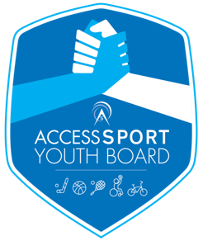
Access Sport Youth Board
Application Form

Access Sport are searching for disabled and non-disabled young people between the ages of 15 and 25 years old with a passion for making a difference through sport to join our successful Youth Board.

What does Access Sport do?
Access Sport believes every young person should be able to take part in sport and physical activity in their local community. We want to help every community sports club be inclusive and open to children and young people no matter their age, background, ability or disability.

Access Sport support community clubs by training and supporting local volunteers to deliver inclusive sporting opportunities. We believe every young person have access to the power of sport!

What is the Access Sport Youth Board?
The Access Sport Youth Board is a diverse group of young people who work as a team to feedback on the work by Access Sport and shape the future plans of the charity. The Youth Board brings together young people from across our projects and support them to develop as individuals and as a group to be involved with decision making and the development of the charity. This is a voluntary role with a commitment to attending four meetings a year, two in person dependent on Covid-19 restrictions with travel expenses covered.

What kind of things do the Youth Board do?
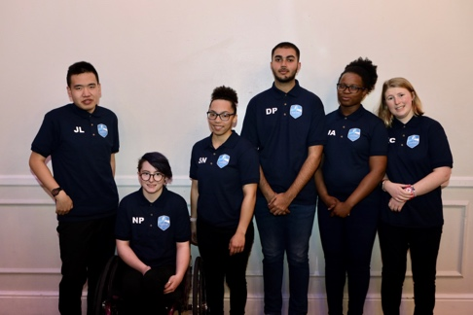
Youth Board members meet as a team every three months to feedback on Access Sport’s work and guide our future plans.

In addition to group meetings, Youth Board members have the opportunity to attend Access Sport events (see photo on the left from Access Sport Annual Dinner), take part in training and have one-to-one buddying with an Access Sport staff member.

What do we expect from you?
- 1-year commitment to the Youth Board, attending four group meetings per year.
- Uphold the Access Sport values: inclusive, empowering, passionate, honest and innovative.
- Be an organised and reliable team player to help the Youth Board achieve their goals.
- Have an interest in taking part in volunteering, training opportunities and qualifications.

What you can expect from Access Sport?
- Commitment to supporting all Youth Board members improve personal and professional skills.
- One-to-one buddying with an Access Sport staff member.
- Access to fully funded training opportunities and qualifications.
- Access Sport Youth Board Adidas kit.
- Opportunities to attend Access Sport events, including our annual dinner where you will meet our sport star ambassadors.

Application Form

To apply, please send your completed application form with your CV to katie.page@accesssport.co.uk. Shortlisted applicants will be invited to our next Youth Board meeting to meet the team and have a short interview led by two existing board members.

If you have any questions or require support completing the application form please get in touch via email or call 020 7993 9883.

Personal Details:
Full Name: | Click here to enter text.
Date of Birth: | Click here to enter text.
Telephone Number: | Click here to enter text.
Email Address: | Click here to enter text.
Location/London Borough: | Click here to enter text.
School/College (if applicable): | Click here to enter text.

Parent/Guardian Details:
Full Name: | Click here to enter text.
Telephone Number: | Click here to enter text.
Email Address: | Click here to enter text.
Location (Town/Borough): | Click here to enter text.
Relationship to applicant: | Click here to enter text.

Application Questions:
Why do you want to join Access Sport’s Youth Board?
Click here to enter text.

List any previous experience related to this role. This may include membership of a group, volunteering, participating and/or paid work.
Click here to enter text.

What makes you a good team player?
Click here to enter text.

What would you like to achieve through joining Access Sport’s Youth Board?
Click here to enter text.

Would you like to be considered for the Youth Board Chair/Deputy Chair?
Yes | ☐ | No | ☐

How did you find out about this opportunity?
Sports Club | ☐ | Friend/Family | ☐
School or College | ☐ | Youth Board Member | ☐
Access Sport website | ☐ | Other | ☐
Social Media | ☐ | Please detail | Click here to enter text.

We look forward to receiving your application.
Thanks for your interest in the Access Sport Youth Board!

