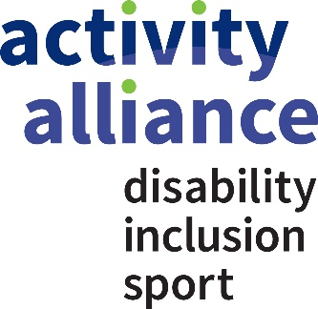

Membership commitment
Your commitment to fairness for disabled people in sport and activity
By signing up to the Activity Alliance’s membership commitment, you are supporting a growing movement for change.
Our vision is fairness for disabled people in sport and activity. We cannot achieve this alone. Working together, we can realise this vision in a shorter time. Across the country, there is a wealth of people and organisations wanting to change attitudes towards disabled people and improve others’ approaches. You can be part of our collaborative movement and ensure disabled people reap the benefits of being active.

Part 1: Your commitment
We are committed to working with Activity Alliance and members to grow the movement for change. We support the charity’s vision to see fairness for disabled people in sport and activity.
By signing this, you agree to Activity Alliance promoting your organisation’s name in our movement lists.
Signed

Position (This must be Chief Executive or nearest equivalent)

Organisation

Part 2: Lead theme examples (for organisations within the sport or leisure sector)
If you are an organisation within the sport or leisure sector, we ask you to work with us on your Lead improvement plan. Lead runs through nine themes:
- Leadership
Effective leadership that inspires an inclusive culture where your whole organisation considers disabled people’s needs.
- Strategy and policy
Strategic plans that are sustainable, linking positive outcomes for disabled people to your organisation’s vision.
- Community engagement
Provide better services by understanding disabled people in your community. Empower more to influence and access your offer.
- Partnership working
Have a greater impact with local disabled people by building effective partnerships with likeminded organisations.
- Resource management
Improving the experience of disabled people by managing and dedicating resources (including human) effectively.
- People management
Build a more qualified and representative workforce to deliver your strategies.
- Service development, marketing and delivery
Identify, reach and satisfy a wider audience through inclusive and accessible marketing communications. Provide an accessible offer.
- Performance measurement and learning
Benchmark your progress by setting targets for effective performance.
- Facilities
Assess how accessible and welcoming the facilities your organisation uses are for activities.
Please use the table below to list example impact stories of your work towards the themes above. This can be links to appropriate online content:
Lead theme | Online link and brief description

Details:
We will contact you regularly to capture your work towards this commitment. Please supply the contact information below.
Name of Chief Executive or other Executive leader

Name of organisation

Name of lead contact

Contact email

Contact phone

Organisation website

Organisation Twitter

Please send to your representative at Activity Alliance.
Contact us on 01509 227750 or members@activityalliance.org.uk

