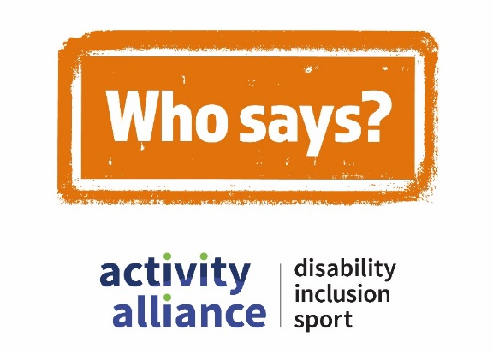

Transcript - Who says? campaign phase two teaser film
This video shows action shots of disabled children and young people being active and playing different sports. While disabled and non-disabled children and adults talk about perceptions of disability, inclusion, and sport. It begins with quick scenes of people’s expressions, reactions, and responses to several negative perceptions.
School pupil, Rainbow: “No I’m sorry, I do not agree with that.”
Cut to shot of a parkour activity session. A visually impaired boy performs a front flip on to a soft crash mat.
Two teenage boys with learning disabilities look at each other with confusion.
Cut to a shot of a young man cruising passed a climbing wall on a zip wire.
Young video game player, Rosie: “Yes they can!”
Cut to shot of an inclusive dance class. Group of young disabled people clap and dance to the music.
Dance class: “Hey!”
Rocket and his mum, Marti, at an inclusive gaming session for children with a range of impairments.
Marti: “Wrong.”
Rocket shakes his head.
Cut to shot of a young person wearing ear defenders catching a ball during a busy games session.
Young man, Owen: “I want to be a boss.”
Cut to shot of an under 16 age group pan-disability football session. Players run across an indoor pitch practicing their football skills.
School pupil, Thomas: “Nonsense.”
Cut to shot of an inclusive gaming session. Children with a range of impairments play video games together.
Young video game player, Dylan: “Are we done yet?”
Who says campaign logo appears onscreen with a stamping sound.
Onscreen text and voiceover reads: “#WhoSays.”
Video ends with Who says campaign logo, Activity Alliance logo, and Sport England logo onscreen.
End of transcript.

