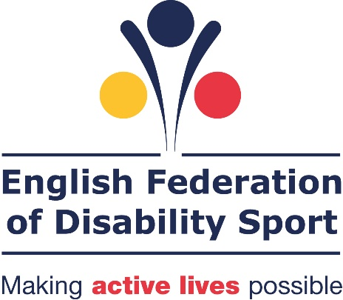

Talk to Me
Principles in action

March 2015
English Federation of Disability Sport

Contents
Introduction 3
The principles 3
Principle 1: My channels 4
Principle 2: My locality 7
Principle 3: Me, not my impairment 9
Principle 4: My values 12
Principle 5: My life story 14
Principle 6 and 7: Reassure me and Include Me 16
Principle 8: Listen to me 18
Principle 9: Welcome me 19
Principle 10: Show me 22

Introduction

In October 2014 the English Federation of Disability Sport released its ‘Talk to Me’ report. This report outlined 10 principles that sports providers could follow to help make their sport or activity more appealing to disabled people.

This document provides examples of ways in which each principle has been implemented in practice.

The principles
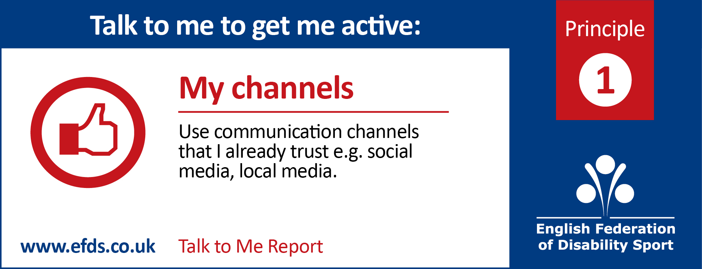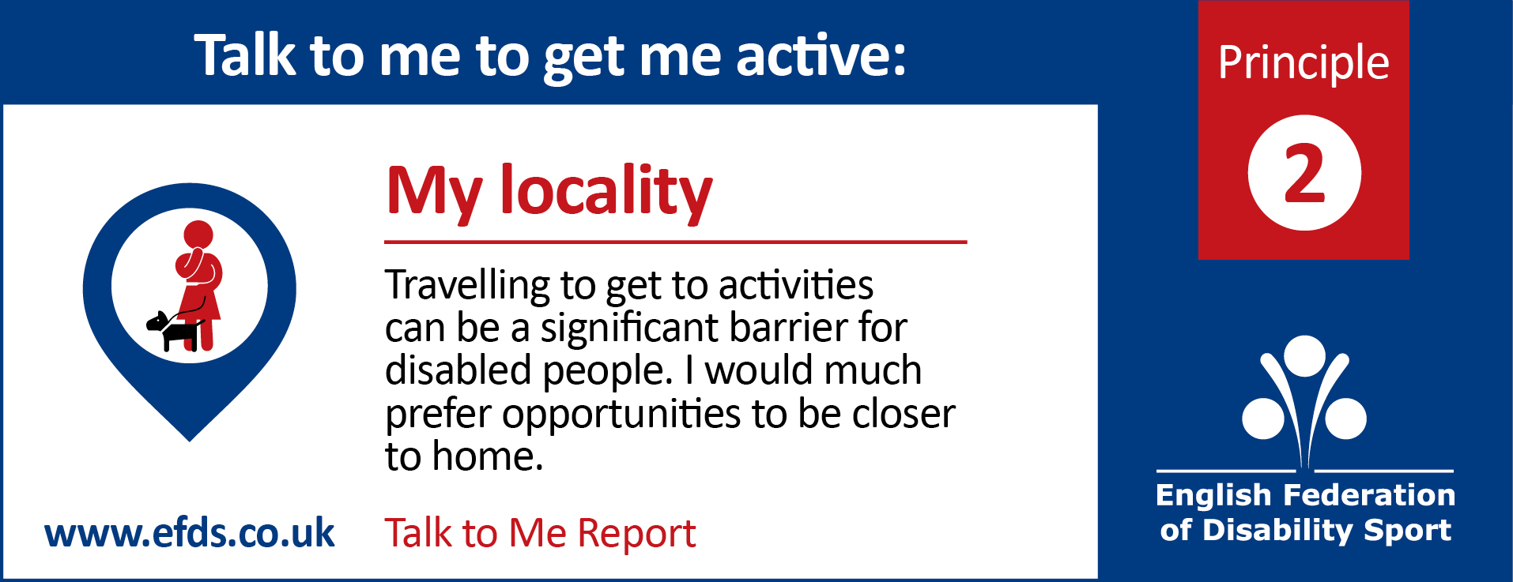
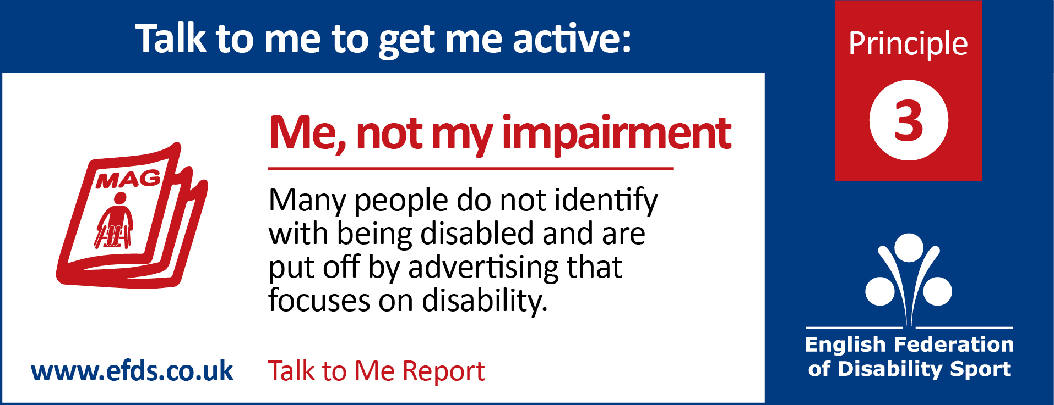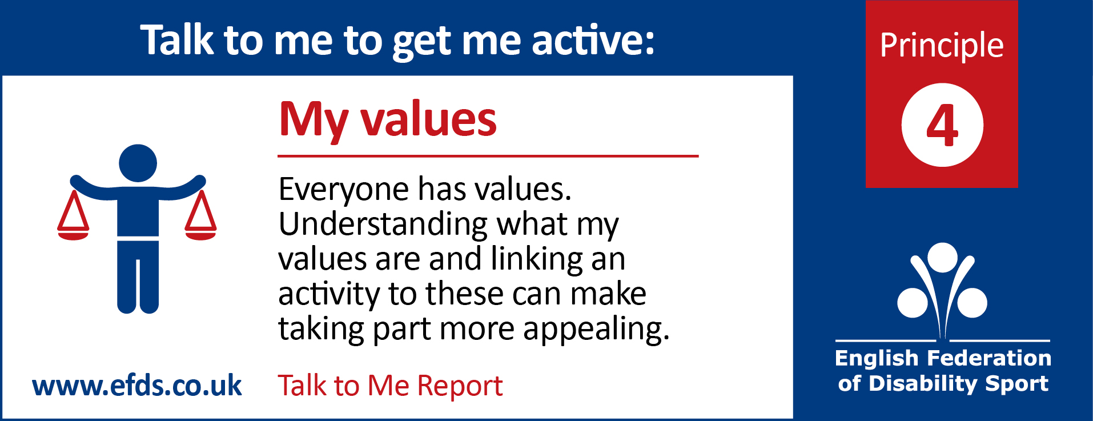
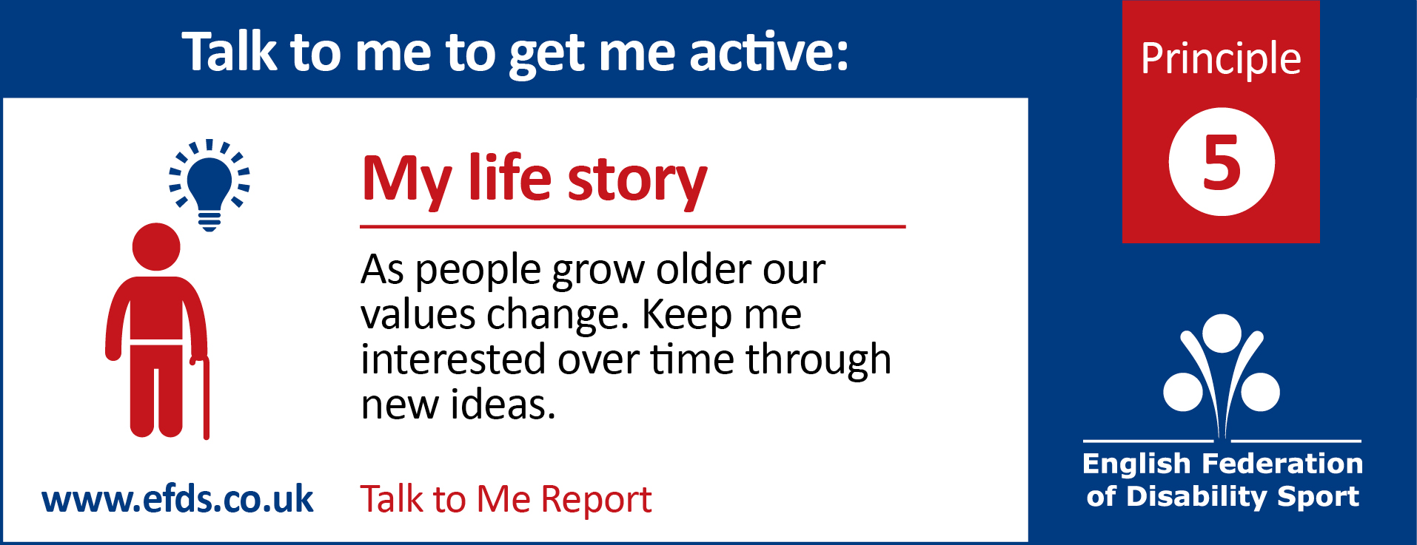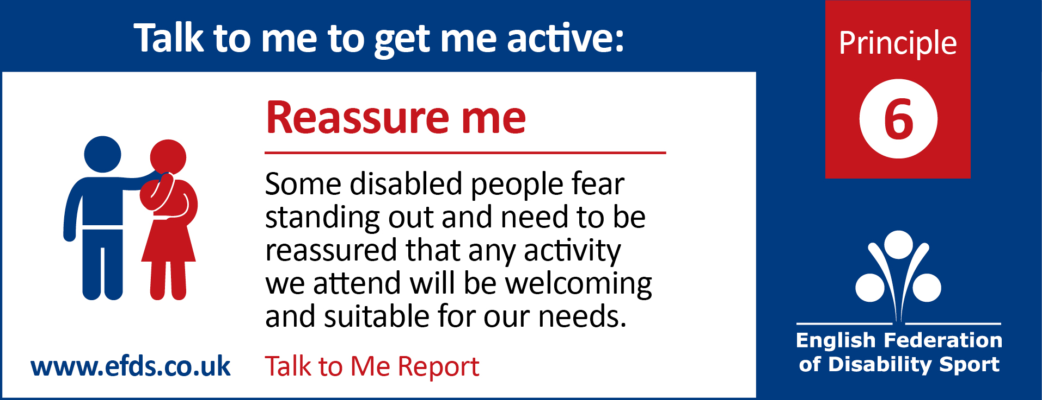
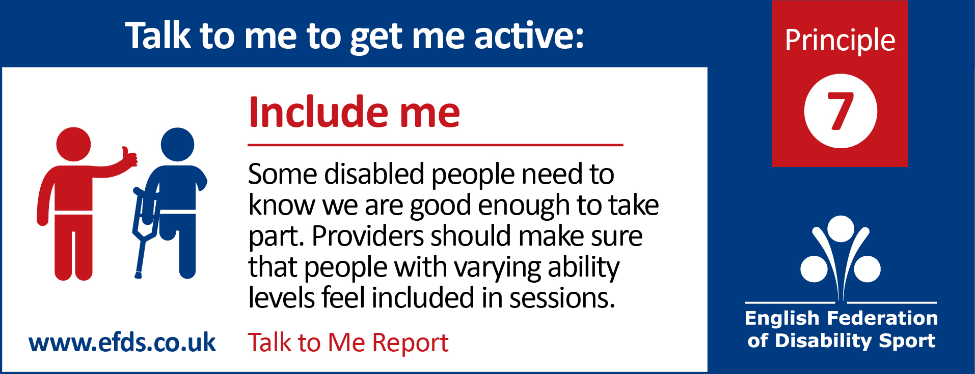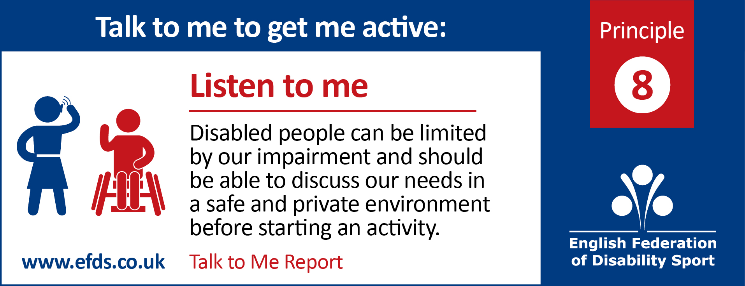
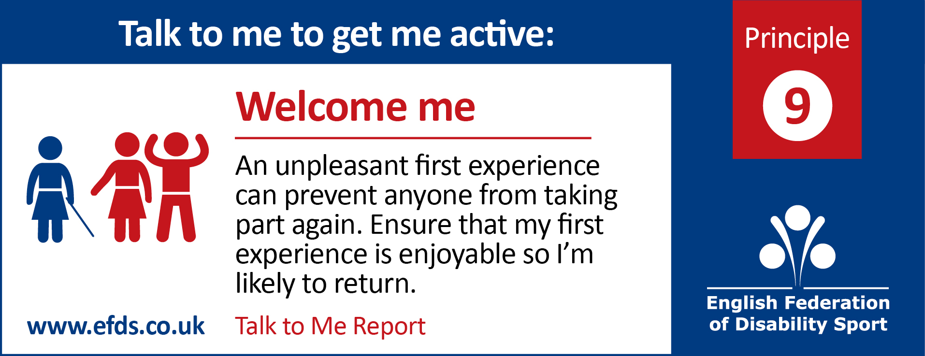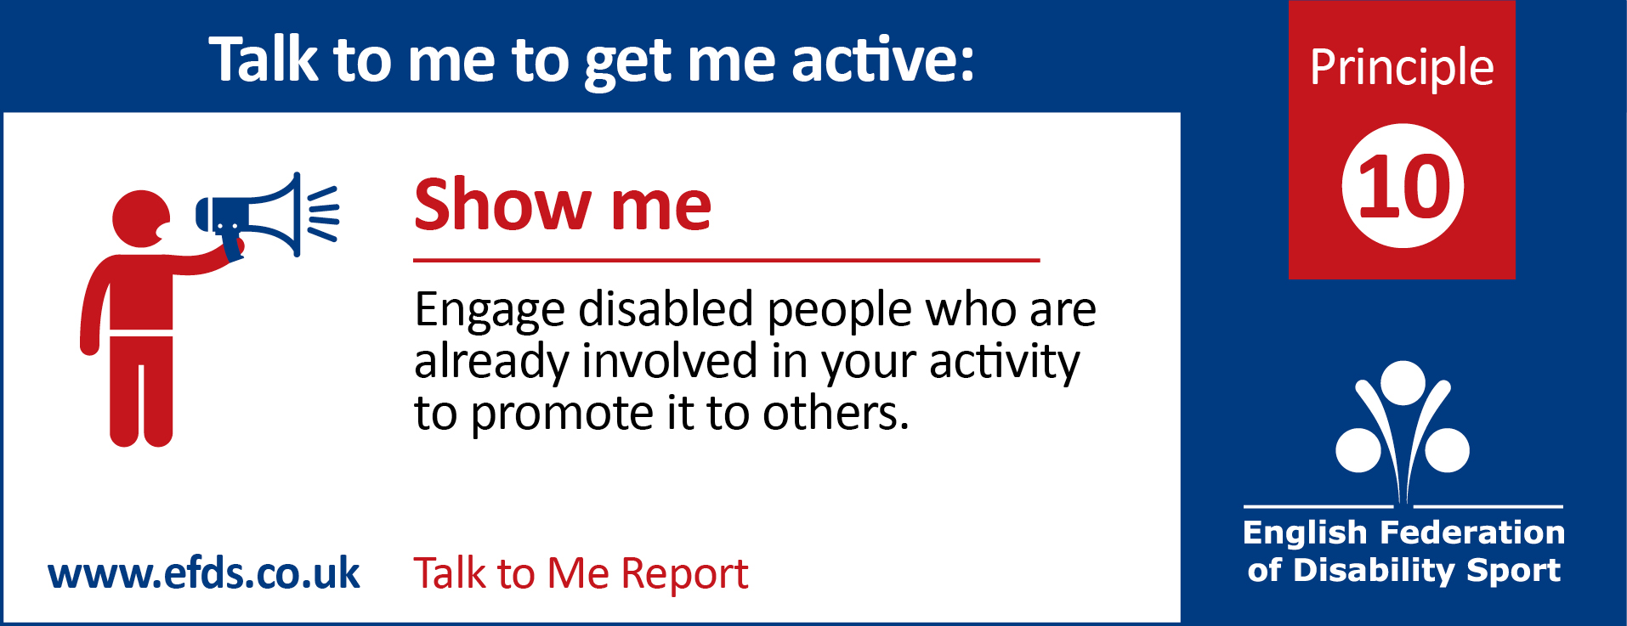

Principle 1: My channels

To reach disabled people simply use the communication channels you would normally use such as social media, local media, posters, word of mouth etc. But don’t rely on just one channel. What you must focus on is to ensure to provide enough information for disabled people to make an informed choice.

Examples of communications that disabled people found appealing:

The use of social media to help people visualise an activity
“I’m always on Twitter and Facebook. Different companies and organisations often post lots of videos of events and different classes which can be so useful for you to see if you think it might be worth it.”

The promotion of an activity at an everyday venue
“It was chatting to a few people from the disabled football organisation standing outside of the supermarket that first pulled me in. We had a really informal chat about it. I told them my worries and they were able to reassure me there and then. I’d only been out to grab some dinner and ended up signing up!”

Links with healthcare professionals
“It was in my doctor’s surgery that I first saw the leaflet for adapted sports- I spoke to him about it there and then and from there I tried to find out as much as possible”

Provider case study
Avondale gym: linking with health care professionals leading to word of mouth
Avondale Gym wanted to increase their membership numbers. One strategy was to increase users in the facility. To do this they decided to use the trusted source of healthcare professionals to get people into the venue.

Michelle Childs, development officer says “we hold weight management sessions here, GP referrals, and whilst they are doing that, it starts showing people, who probably wouldn’t come into a gym, it starts a hand holding process”

And once people have attended and enjoyed a session word of mouth takes over. Jamie Mccord – General Manager says “Because you have those groups coming in and seeing what you have, they do your referral for you. So things grow more organically.”

The centre has been clever about how it programmes its timetable to encourage increased use of the facilities: Childs states “We have a weight management class here on Wednesday. The chair based exercise class starts straight after across the hall. So as people leave they see people just like them that they can relate to going into an exercise class. And when in the sessions, you can hear them talking, saying ‘why don’t you go to the aqua class on Monday as well?”

Provider case study
Using social media to increase awareness: British Wheelchair Basketball social media challenge 2014
BWBB ran a competition to recognise and reward clubs who promote the sport through social media. Prizes were offered for clubs who had the:
- Best Promotion of the Sport
  - Content that captures and portrays the sport positively
  - Demonstrating that you’ve reached new audiences
  - Engagement with the press and media
  - Links to Partners
- Best Engagement of Members
  - Promotion of social media channels within the club (kit, signage, programmes etc.)
  - Demonstrate active discussion between club and members as well as member to member
  - Sharing of content that is valued by Members
- Best use of Social Media for Fundraising
  - The use of innovative content
  - Ideas to promote the cause
  - The amount raised (please note the award won’t necessarily go to the club raising the highest amount)
  - Engagement of strategic partners and links and support
  - The winning club for each category demonstrated the following:
- Best Promotion of the Sport
  - An imaginative approach to communicating with members: sharing dates, training tips, videos and social plans
- Best Engagement of Members
  - Selfies, club features, local media
- Best use of Social Media for Fundraising
  - Use of social media to raise money through mugs for Christmas, easyfundraising and sponsoring mountain climbing players

Principle 2: My locality

Disabled people are keen to have activities which are local to them mainly because of the increased challenges they face with transport.

‘There is already so many struggles with taking part in sports without having to worry about getting there. I need something local to me, somewhere I know I can get to easily and not have to worry’

Disabled people are often keen to take part in sport or activity, and are willing to pay to do so. However the potential issues or transport, particularly the cost, can be a significant limitation.

‘Don’t make the activity free. We’re willing to pay for the activity. The issue is the transport to get there. If there is funding, use it to subsidise that’

Provider case study
Berkshire County Blind Society: Bus transport system
A visual impairment charity in Berkshire has developed a strategy to help overcome the issues with transport.

Berkshire County Blind Society provides a transport service. They make sure to include transport costs in all grant applications to generate finance to support the scheme. They then use a mix of community and their own minibuses driven by volunteers to collect people to go swimming.

Having local opportunities is useful, but only if disabled people are aware that they exist. Knowing what else is available in the area is also useful for providers, to help them decide whether there is a demand for their activities, or gaps in the market for new offers.

It is therefore helpful if there is some form of system available to monitor and advertise what is available at a local level.

Provider case study
Creating Connections, West Yorkshire Sport – Reaching out to the locality
West Yorkshire Sport has employed district officers who are tasked with identifying local opportunities in their district and creating a local directory.

These district directories are then brought together into West Yorkshire wide directory. This enables specialities across sub regions to be identified as well as highlighting travel needs which may across boundaries.

Knowing what is already available has allowed West Yorkshire Sport to focus on market development. They have been able to identify gaps and then work with clubs and providers to expand their local offers

Provider case study
YOU CAN community club: taking local children to enjoy outdoor pursuits
A youth club for disabled people based in Greater Manchester has established a strong link with local outdoor activity providers to allow their members to experience new and different activities.

The youth club provides a local safe and inclusive environment for young people to get together, have fun, try new things and learn new skills.

They provide a service which takes people from the youth club to outdoor activities in the nearby area. The young people feel safe and confident in taking part in these new activities because they are doing so from the safety of a familiar and known environment with staff and peers who they trust.

Provider case study
Satellite Clubs – bridging the gap between school and community sports
Satellite clubs are extensions, or outposts of community sports clubs which are established in a new venue, usually a secondary school or college and specifically target the 11-25 age group.

The club is linked to a local community club. By holding the club is the school or college takes the sport or activity to young people in a setting that they feel comfortable and familiar with. Somewhere they are used to travelling to and know that they can access and get around.

Satellite clubs make it easier for young people to stay in sport by providing a stepping stone to community activities and more regular participation.

Sport England has developed a satellite club guidance document for community sports clubs on how to plan, establish and sustain a successful satellite club.
http://sportengland.org/satelliteclubs

Principle 3: Me, not my impairment

Advertising an activity by focusing on disability or a person’s impairment can be a turn off to some disabled people for example ‘disability football session’.

“It sounds a bit rubbish really, like you’re not really going to have fun”

“The difference for me is, when the focus is a disability, I think it can attract a range of people who want different things out of a club. When you get something where the focus is participation or competition you get people of like minds.”

It is important to use words and images that resonate with people.

“When I read something like that poster, for me it’s just talking to wheelchair users.” Jane

Instead of focusing on their impairment or disability in the main headlines, focus on other values or key selling points of the activity. References to disability and impairment can be made in the content of the poster, but should not be the main focus.
Provider case study: Example of a poster which does not focus on disability
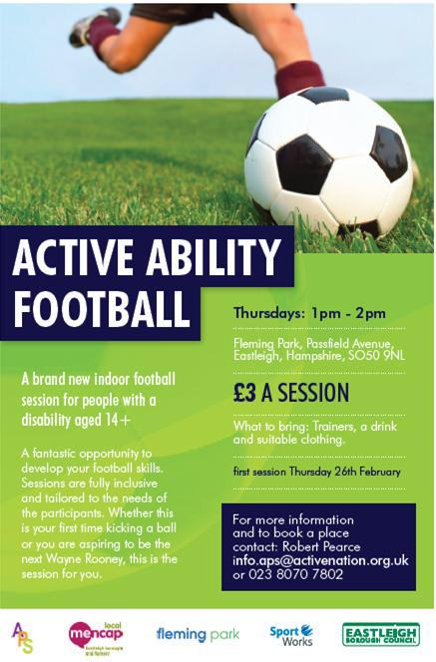

Try and attract the attention of people to your activity by advertising the benefits of taking part.
Provider case study
Liverpool Lions – wheelchair rugby team
Liverpool Lions wheelchair rugby team were struggling to attract non-disabled people. To try and boost numbers, the manager of the team approached the local under 16s rugby league team and asked them if they wanted to come and try wheelchair rugby and use it as part of their training.

The team manager said “We told them it would be good for their coordination. It can also give them a really good upper body workout.”

By highlighting the benefits that the sport can provide, 5 or 6 members of the under 16s team now regularly take part in the wheelchair rugby sessions as an additional training session.

Participant case study
Trevor – member of an all ability cycling club
When younger, Trevor was a keen cyclist, but at the age of 19 he was knocked from his bike and ended up with long term injuries which resulted in partial paralysis. After the accident he was unable to get on a bike so stopped cycling. He missed cycling and “the feel of the air flowing past my face which meant I was moving at speed”

Many years later he saw an advert for an all ability cycling club which promised ‘to get anyone on a bike’. His interest was piqued and he decided to go along and test whether the cycling group was indeed for ‘all abilities’. To his delight he found that it was. The group had a range of varied bikes with different adaptations that meant anyone could come and take part.

Principle 4: My values

When promoting a new activity think about the reasons why someone would want to come and take part. What motivates them to consider taking part in sport or physical activity?

Our research has identified six main values that motivate disabled people on a daily basis.

Figure 1: The values of disabled people
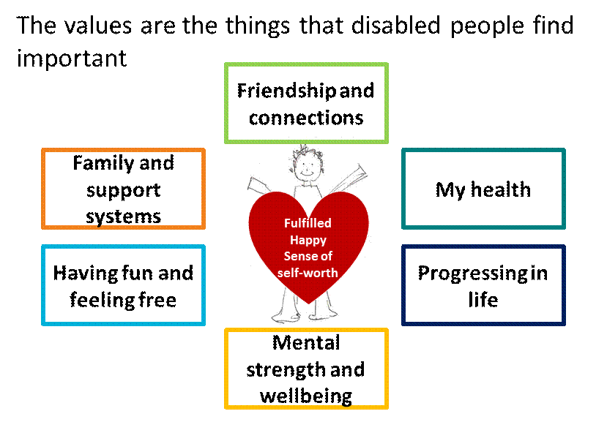

By providing activities that can be linked to these values, people will be more engaged. Linking to more than one value will make an activity more appealing.

Think about offering different activities which appeal to different values, where sport and p physical activity are part of that offer

Participant case study
Maria: what rowing means to her
Maria is 36 and she has multiple epiphyseal dysplasia which means she is short in stature and has mobility issues.

Maria really enjoyed watching the 2012 Paralympics and became very interest in rowing. Maria started to look into taking part in rowing in her local area. She saw a tweet from a local rowing club which said ‘Would anyone be interested in adaptive rowing, let us know’.

Maria said “So I did, and I have never looked back since. I had such a passion for what the Paralympians were doing. I wanted a bit of the glory, the excitement, the friendship and the camaraderie that they had. I’ve felt that was a huge part of my life that was missing

For Maria, being part of a rowing team connects to many of her values.

Provider case study
Hallamshire Tennis Centre: community tennis sessions
When thinking about creating new activities within their centre the Hallamshire Tennis Centre in Sheffield always try to ensure that each session:
- Enhances communities
- Promotes social inclusion
- Improves quality of life of those that attend
- Increases skills and creativity of those that attend
- Increases aspirations and achievement of those that attend

They like to think above and beyond the sport itself at other things that people can get from taking part.

Participant Case Study
English National Ballet – Dance for Parkinson’s – Helena and Anne’s story
Dance for Parkinson’s is a regular weekly programme developed by the English National Ballet and delivered in several locations across the UK by associated partners. It provides an opportunity for people with Parkinson’s, their carers, friends and family members to engage in artistic dance activity inspired by ballet.

Helena and Anne are two sisters who attend a session in Liverpool. Helena has Parkinson’s and her sister, Anne, travels to meet her each week. The women started to attend the session after Anne saw the details of a London based class on TV and suggested that they attend a locally run event as a way for Helena to manage her condition

Whilst the initial drive to attend the session was as a way for Helena to manage her condition they have both seen additional benefits. The sisters look on the sessions as an excuse to spend time together with additional benefits. They make a day out of each session, going for lunch before heading to the class.

Helena admits it is not something that she would probably do alone but finds it easier with her sister’s support. She likes attending because the classes are open to all ages, abilities, and genders and welcome carers and companions. It’s a very social atmosphere with lots of humour and fun included.

Helena says “I really enjoy the coming together of personalities in the class. You find out things about people – it’s a spiritual connection really. The teachers enjoy their time with you just as much as you are enjoying being with them. There’s a strong sense of commitment and community”

“When I leave this class I’m glad I’ve been and I want to come again; it’s not miraculous; it’s not a cure; but I keep coming because I enjoy it, I have a day out and when I get home I feel it’s a day really well spent, I’ve learnt something new, I’ve expressed myself, I’ve seen my sister, and I have a good night’s sleep – satisfaction! I wouldn’t miss it for the world”.

Anne has also seen personal benefits “I come to support my sister but I have gotten a great deal out of it myself actually! There are many health benefits to me generally as an older dancer even without Parkinson’s; I find myself more confident to join in with other activities and have enjoyed learning about a new art form immensely. It’s an incredible rich experience with many layers.”

For more information on one of these classes contact 0207 581 1245, email learning@ballet.org.uk, or visit the website: www.ballet.org.uk/parkinsons

Provider case study
Jigsaw – Heart Smart 2 – aiming to give members to independence to lead healthier lifestyles
A sports and social group for young disabled people is set to launch the final stage of a year-long project funded by Heart Research UK. After the success of the first project, the group received a £9,000 Healthy Heart Grant, aiming to give members of the group the independence to lead healthier lifestyles.
To date, the project has seen nearly 90 people aged 13–30 and their families engage in activities which can reduce the risk of heart disease, with more people set to take part in the project's final stage.
Activities already undertaken have included sports sessions but also fun and interactive cookery session and healthy heart workshops covering topics such as salts and sugars, fats, food labelling and portion sizes.
The mix of different activities offered meant that the program had an appeal to a wide variety of people, engaging them with one activity but encouraging them to try other things, or do more of the same.
Ellen Smith, aged 21, who is the administrator and a group leader at Jigsaw, encouraged her father Paul to get involved with the project, which resulted in the duo completing the Great North Run on behalf of Heart Research UK.
Staff, participants, carers and volunteers attended a recent friendly rounders match at Bury Athletics track, which proved such a success, that Jigsaw hopes to make a sports tournament or family sports day part of its yearly calendar.
Heart Research UK national director, Barbara Harpham said: “We’re delighted to be able to support Jigsaw’s second heart-focused project, having seen the success of the first one in helping young disabled people to improve their heart health.”

Principle 5: My life story

As people grow older and progress through life, the values that they have and the things that motivate them change. It is therefore important that an activity can appeal to different values so that it continues to appeal to people over time.

There are many ways in which sport and activity can appeal to people, below are some examples of why disabled people play sport and how providers can offer something new.

Participant case study
Tracey: playing sport to spend time with her son
Tracey has a teenage son. As he has gotten older he spends less and less time with the family. They have recently found a common ground where they enjoy playing squash together

Tracey says “playing has helped me with the relationship with my son. He’s 13, almost 14. He’s now at that age where we barely see him. He comes home, goes upstairs on his Xbox, and comes down when he wants some food and disappears again. He likes playing squash. So we book a game every couple of weeks. He likes the challenge of being able to say he beat me, and I get to talk to him about his day.”

Playing squash offers them an opportunity to spend time together, a value that has become more important to them as the children have got older and have their own social lives.

Provider case study
Contemporary dance class: skills and experience above and beyond dancing
A contemporary dance class in Liverpool runs a scheme called Peer Educators, which uses young people from the class (aged 14 upwards) who want to be more involved in the programme.

These young people help support and lead the classes. They ensure no one is left out or confused. They are trained in supporting young people; how to listen and how to be empathic. Their role is to help the young people to express their ideas, especially the young disabled people.

The peer educators attend open days and creative sessions at local schools. Here, they lead warm up exercises and help to promote the dance class. They perform as a dance company, often with complex routines. They then mix and talk to people in the audience.

It provides the individuals with empowerment and a sense of achievement. It also lets the other disabled participants see what can be achieved.

“You see the other disabled people looking and thinking ‘I want to do that’. It becomes a stepping stone. Some of the younger ones look up to them and think that is what they want to do.”

Provider case study
Walking Football: football aims to inspire the over 50s to get out of their armchairs and back into exercise.
Conceived in 2011 by the Chesterfield FC Community Trust, walking football was designed as a way of tackling both inactivity and social isolation among older men. Activities for older people, such as tea-dances and sit-down aerobics, tend to be dominated by women and shunned by men. There was a clear gap in the market.

The success of the sport is capturing what is important to men. As outlined by Roger Jones one of the pioneers “The success is down to capturing men’s passion for sport. Men like being with other men, they like the banter, they want to be able to swear and fart.”

Walking football is a slowed-down version of the game with some minor rules changes:
- The squads are smaller (between five and seven-a-side),
- Free kicks are indirect,
- Kick-ins replace throws,
- There are no offsides,
- The ball must be kept below head height
- Anything so much as a jog is prohibited, resulting in a free kick to the opposite side

The pace of walking football may be more leisurely, but the game is still fierce, and provides participants with great camaraderie.

The sport’s biggest appeal is the walking element as it means games can accommodate a much wider range of fitness levels and abilities than the traditional form of the game. It helps to recapture people who used to play football but had to stop because it was so strenuous. Now they have something they enjoy

The programme has been a success with over 400 clubs now in the UK. The emphasis on fun is what has driven the success so far. But some people are now pushing for more competition which people are concerned may dampen the enthusiasm for the sport

“Competition would kill off the grass roots stuff. People would think they aren’t fit enough to play. Two years ago we were all very unfit, now look at us, we still might not be that fit but we’re having fun. We’re afraid that if the FA formalised it that might lead to an over regimentation that would take the fun out.” Tracey Humphries – Age UK North Staffs

This shows adapting the sport to meet the changing needs of participants can be extremely successful, but try not to lose sight of the reasons that people participate

Principle 6 and 7: Reassure me and Include Me

Disabled people may dismiss sport or physical activity because they think that they do not have the skills or ability to take part. They are fearful of taking part and being made to stand out – something which can be a much greater barrier than their impairment

"I don’t like going to disabled only classes, but when thinking about going with people without impairments I think I’m not going to be able to keep up with everybody else- sometimes I know I’m being silly but it really puts me off. I don’t want to be singled out but I want other people to make me feel welcome regardless of my ability.”

It is therefore important to provide enough information to reassure disabled people that the activity is suitable for them, at a level at which they will feel comfortable.

Provider case study
Avondale Gym: using social media to show what the facility has to offer
A gym in Great Manchester uses social media to help promote its activities. They create case studies of some of their members, using photos and videos, and post them on Facebook so other people can see what the facility provides and how people use it.

Michelle Childs the development manager states: “These show local people. Those are the posts that get the most likes, the most retweets, the most shares.”

By doing this they provide a visualisation of the actual facility with real people attending. It helps people determine whether they would fit in or not. As a gym member said: “Being able to see it in action, see different types of people taking part so you feel more comfortable.”

Provider case study
Hallamshire Tennis Centre, Sheffield, community tennis sessions
To ensure that disabled people feel comfortable with their sessions the tennis club provides taster sessions for people to come and see the activity in action.

The taster session is free. People can come along to the club at a given time. They can meet the coach first and chat with them. They are able to ask questions in a relaxed and informal manner. They are shown around the club before stepping on to the tennis court for the session.

This gives them the chances to assess whether the club is suitable for them before they even start to play. They are given the opportunity to ask questions to help alleviate any concerns they might have.

Provider case study
Martial arts: adapting the session for different abilities
Christian is a martial arts instructor and provides inclusive martial art sessions. To ensure that everyone at this sessions has the best experience he adapts exercise to different levels of ability, so people can take part together, but at a level they are comfortable with.

Christian says “every session you do, you have different levels. So what I would do is- I would introduce them to a low level, and then I would slowly move up. Once a person finds the level that they are happy training at, they stay there or continue. I show them the other options for those that want to push it a bit further.”

Provider case study
Access Dorset – videos demonstrating people taking part in activities
Access Dorset is a user led organisation and registered charity, run by disabled people, older people and carers.

They have a website where they advertise suitable activities for disabled people to take part in. On this website they have a number of videos which demonstrate the different activities available

http://www.accessdorsetcentre.org/fit-for-life-films/

The videos film the activities takin g place and include interviews with participants and the activity leader. People can watch them and get a better understanding of what to expect and the kind of people who attend.

Having people who attend the class and give feedback of their experience also help people understand what they can get from it. It also shows the progression people can make by taking part – such as becoming an instructor themselves.

Alongside the videos contact details (a phone number and an email address) is also made available for people to be able to ask additional questions before they attend

Principle 8: Listen to me

Disabled people want their needs to be known without being singled out or prevented from participating. Our research has highlighted that disabled people feel more comfortable and confident if they know that an instructor or leader is aware of any limitations that they may have as they feel that they will be more prepared to provide them an enjoyable experience.

“Being able to tell an instructor my needs and my limitations before a session. I think I would need to be asked though. I wouldn’t be confident to go and tell him without being asked”

Provider case study
Avondale Gym: letting people give feedback
Offering disabled people an opportunity to give feedback on how you can better meet their needs is essential. Avondale gives their users various ways in which to share their views.

They do online surveys with their members as well as encouraging members to speak to staff about anything that they think has been done well or needs improving. They also have something called the ‘You say’ wall. A mobile pop up feedback wall. It is moved around the facility and people are encouraged to add feedback to it. They don’t have to write their name, it gives them an anonymous forum to share their views.

Participant case study
Park Run – giving visually impaired people the chance to explain their needs
John was keen to be more active, but as a wheelchair user and visually impaired he was struggling to find opportunities that were suitable for him in his local area.

He contacted Northamptonshire Sport (his local County Sport Partnership) to ask what was available. They suggested he try his local Park Run which was 5 minutes from his house.

John had some concerns about his ability to complete a Park Run, so Northamptonshire Sport worked with John and Park Run to help John understand more about the run and how he could take part. A request was then sent out across the ParkRun network to ask for volunteers who would be willing to train with John as his guide and to help him build his fitness.

8 volunteers came forward. A meeting was arranged for the 8 volunteers to meet John after a Park Run to be introduced to each other and practice working together. This allowed them to build an understanding of the verbal and physical signals that could be used during the run to help John get around the course.

John then attempted his first park Run with 2 volunteers helping him. He pushed himself as far as he could go and then the volunteers would take turns pushing him the rest of the way. His goal is to push the whole 5km course. After completely two Park Runs he can already manage 3km so is well on the way to achieving his aim.

Principle 9: Welcome me

An uncomfortable or awkward first experience can put people off coming back again. It is important to ensure that people have an enjoyable first experience, and to remember that experience is not just about taking part in the activity itself. The first experience includes getting there and arriving at the venue. All staff people encounter. Going into and using the changing rooms and other facilities. Meeting other members of the session for the first time and the ‘instructor’ and the suitability of the class for their skill level.

“I went swimming and just getting from reception to the changing room was so hard. There was no one there to help me. It really put me off gong back.”

Providers need to make people feel comfortable

Provider case study
Sitting volleyball buddy scheme
A sitting volleyball club run a buddy scheme. When a new member shows interest in joining the club, they take their contact details and pass them on to another club member who is their ‘buddy’. The buddy’s role is to make the new person feel welcome.

They can text them to check if they are coming to a session, ask them if they want to meet beforehand to go into the session together, maintain contact after a session saying it was nice to meet them and that the look forward to seeing them again the following week.

Current members think that the scheme works really well. “It’s a great thing as you feel part of the club.”

Provider case study
Inclusive Fitness Customer Service Training
If staff attitude and organisational culture is not inclusive then this will prevent many users from using or getting much further than the front door of a facility.

An unwelcoming environment can affect most people’s impression of a business, facility or club. More than eight in 10 disabled customers have taken their business elsewhere after experiencing poor customer care.

As a result, many organisations are missing out on the numerous benefits that disabled customers can offer as a large proportion of our population.

Staff training created through EFDS’s Inclusive Fitness Initiative (IFI) programme will support more organisations to reap the rewards of satisfied disabled customers and make active lives possible.

‘Delivering excellent customer service for disabled customers’, an online staff training module created through EFDS’s Inclusive Fitness Initiative (IFI) programme is available to organisations to help upskill them in proiding for disabled people so that they can enjoy the benefits
http://www.efds.co.uk/inclusive_fitness/staff_training

This training explores inclusive customer service, perceptions of disability, effective communication, legislation and much more. Completing the course can help to ensure everyone plays their part in creating a welcoming environment for disabled people.

Provider case study
Northumberland Club VI tennis day
A tennis club in the North East, with support from the Tennis Foundation, implemented a follow up email scheme when people registered to take part in a visually impaired tennis session they provided.

They intended to provide a tennis session for people with visually impairment, welcoming people with different capability levels. When people registered their interest to the session they were sent a follow up email containing lots of useful information including:
- Confirmation of the date, time and location details of the session
- Detailed information on how to get to the session, train times, distance from the station, cost of taxi, information about facilities in the local area.
- Passing on details of other participants and travel arrangements so that they could arrange to meet and travel to the session together
- Explanation of the session and how it would be ran, timings including breaks and details about refreshments and information of the instructors present and their experience
- Explanation of what to do to ensure staff can provide the best possible support for them on the day (expressing their communication needs)
- Information about what to do if they intend to bring a guide dog
- Providing a variety of different contact methods (email, two phone numbers and twitter contact) for people to get in touch

Giving this additional information lets participants know what to expect and also gives them an opportunity to ask further questions if they have any.

The emails were a success and saw 100% conversion rate from sign up to attendance at the course, something they have never seen before when providing such activities.

“It definitely worked as they had a conversion percentage from sign up to attendance of 100% (which has never happened before) and then the highest number of attendees ever on a VI Camp (46)” Matt Elkington, Tennis Foundation Disability Development Manager North & Midlands

Provider case study
Colwick Park Adventure Centre: Making people feel welcome
A group of young adults with learning difficulties attended a free session at Colwick Park Adventure Centre. An experienced instructor met the participants at the gate and talked to them about what it was they were taking part in for the day.

The instructor gave a step by step description of what they would have to do to get in and out of the walking from getting changed into buoyancy aids to walking down to the canoes and carrying them to the water. This meant that the participants knew what was going to happens they were able to relax, enjoy the session and left having had a positive experience.

Principle 10: Show me

The best way to encourage people to get involved in your session is to use the people who are already involved and enthusiastic about you to promote it. If you already have disabled people who are members, get them to share their story and show other disabled people how they can take part as well.

Provider case study
Canoeing club, south coast
A canoe club on the South Coast has found that a good way to attract new disabled members is to offer taster sessions. These sessions allow people to come along and have a go at the sport as well as talk to people who are already involved.

“Our adult taster sessions programme runs during the summer. It is immensely popular. Often we will have 60 people going through a one-day taster session. They’re all completely new to the sport” (Provider, canoeing)

Current members help to run the taster sessions, acting as coaches as a go to point for questions. The people who attend the open day find it really useful to have people to ask questions of, people like them, who once upon time didn’t canoe.

Provider case study
Enthusiastic paddlers who happen to be in a wheelchair share their love of the sport
Bob and Ali are coaches at a canoe club based in Amble in Northumberland

They paddle everywhere together on the local rivers, lakes and sea in the North East and further afield to Scotland.

They are both wheelchair users and have decided to tell their tales through a series of talk shows delivered to coaches and paddlers across different events in the North East. They have inspired many through their humour and wit and sheer determination to get on with it and enjoy their paddling. They tell of their experiences, close shaves and what works well for them and what can be done to help others.

If you have any examples that you would like to share, please get in touch with Emma Spring, our Research and Insight Manager
espring@efds.co.uk
0161 2005442
07817 787542
Twitter @EFDSInsight

Join our insight panel
EFDS is always looking for disabled people’s support on our insight projects. There are many occasions we may get asked to help with other organisations’ research or for our own development plans.
If you would like to join our panel of disabled people, please contact us on research@efds.co.uk or 0161 2005442. It will be mainly communication via email or telephone, so you do not have to commit to any unnecessary time or travel.

