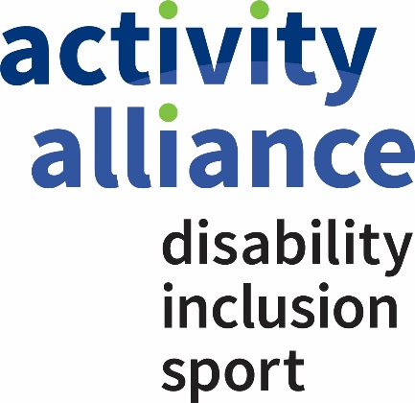

Activity Alliance Equality, Equity and Diversity Statement

Activity Alliance will continue to build towards a diverse and inclusive culture that recognises and develops the potential of all stakeholders.
We recognise the business benefits and opportunities of having a diverse community of Board members and staff who value one another and realise the contribution they can make to achieving Activity Alliance’s vision ‘Making Active Lives Possible”.

Activity Alliance will have a Board that is representative of those it serves with an appropriate gender balance and strong representation from both disabled people and BAME communities with at least one Equality, Equity and Diversity Champion.

Activity Alliance is committed to equality, equity and diversity in all its activities promoting inclusive processes, practices and culture in line with the equality principles set out in the Equality Act 2010.

We will eliminate any unlawful or unfair discrimination including direct or indirect discrimination, discrimination by association, discrimination linked to a perceived characteristic, harassment and victimisation.

We will remain proactive in taking steps to ensure inclusion and engagement for all the people who work for and with us. This includes promoting equality and diversity for all people, but in particular for those identified in the Equality Act (2010) with the following “protected characteristics”:

- age
- disability
- ethnicity (including race, colour and nationality)
- gender
- gender reassignment
- religion or belief
- sexual orientation
- marriage and civil partnership
- pregnancy and maternity

This policy statement applies to all staff, beneficiaries, trustees, volunteers and those with whom we work in partnership.

Review
Date of review: 21 November 2018
Date of next review: 27 November 2019

