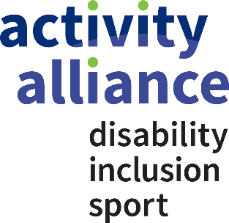

A brief guide for healthcare professionals who would like to support patients who are disabled to get active
If you have watched Activity Alliance’s film Healthcare professionals, making active lives possible and are wondering how you can support disabled people to reap the physical and mental health benefits of being active. Here are some simple things that you can do:
- Feel comfortable discussing physical activity with your patients
- Know and use the messages in the Chief Medical Officer infographics for physical activity. There is a specific infographic for physical activity for disabled adults.
- Access the Clinical Champion Training provided through PHE and Sport England’s Moving Healthcare Professional programme. The training focuses on the evidence base for physical activity (both the prevention and treatment of conditions) and how to provide brief advice and support to patients in clinical practice. Over 22,000 healthcare professionals have already accessed the training and are benefiting from the knowledge and skills provided. Contact the Moving Healthcare Professional team at physicalactivity@phe.gov.uk to find out when sessions may be taking place in your area.
- Organise Clinical Champion Training in your area. Contact PHE’s Physical Activity team and organise a Clinical Champion Training session for you and 19+ colleagues who are interested in embedding physical activity in clinical practice. Contact the team at physicalactivity@phe.gov.uk.
- Access nine e-learning modules for healthcare professionals available on the British Medical Journal E-learning website to learn more about the evidence for physical activities role in preventing and treating long-term health conditions. Over 100,000 modules have been completed since 2014.

- Embed physical activity discussions in your clinical practice
- Use the Moving Medicine platform to help you have physical activity conversations with your patients. This resource is an evidence based physical activity platform, developed by the Faculty of Sport and Exercise Medicine in consultation with professional bodies and expert partners such as health charities. It provides healthcare professionals with access to disease-specific evidence on the role of physical activity. It provides advice and scripts for how to bring up conversations, tailored to the patient in question (based on motivations, barriers and where applicable, health condition).
- Complete the Promoting Physical Activity in Primary Care e-learning module and embed the approaches in your practice. You can access the module here
- Use the Royal Society of Public Health and Public Health England’s Everyday interactions toolkit to help you deliver brief interventions and record the impact of the conversation and signposting to services

- Promote local physical activity opportunities and collaborate with the deliverers in your local area
- Contact your local Active Partnership or Local Authority to find out more about the inclusive physical activity opportunities available for people in your local area and signpost people to the ones that they are interested in. You can also use Activity Alliance’s activity finder.
- Use Activity Alliance’s resources and those developed by other health and disability charities and professional bodies (e.g. Macmillan, the Chartered Society of Physiotherapists and the Royal College of GPs) to promote physical activity to disabled people.
- Provide information about the activities available locally for disabled people in your waiting room.
- Consider if there are opportunities to collaborate with local activity deliverers and disabled people to develop activities. For instance could a walking session start from your practice? Could your waiting room be used to deliver some taster sessions? Could your team volunteer at some activity sessions?

