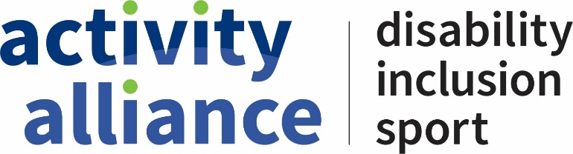

Membership application form
Please complete the information below for your Activity Alliance membership application. We will use your lead contact details below as the main point of contact.
Date
Organisation name

Lead contact
Name
Telephone
Email

Organisation contact details
Address
Tel number
Email
Website
Twitter
Facebook

Membership category (check box):
☐ Full member
☐ Local member
☐ Associate member
☐ Individual member
If unsure, please tick this box ☐

What is the focus of your organisation? (Max. 100 words)

Please tell us about your organisation and work with disabled people? (Max. 100 words)

Why does your organisation want to be a member of Activity Alliance? (Max. 100 words)

How do you already engage with Activity Alliance? (This could be using our resources or through our programmes). Are you involved in any Activity Alliance networks? Please let us know below. (Max. 100 words)

Your checklist:

We have completed the Membership Commitment form: ☐
We have compiled a Lead improvement plan using Lead cards (Sport/leisure orgs only): ☐
We agree to take part in Activity Alliance’s stakeholder surveys if and when required: ☐

Please sign up to our newsletter here

Activity Alliance office use only
Membership Commitment signed Yes ☐ No ☐
Membership approved: Yes ☐ No ☐

If no, what must be reviewed or changed?

Membership reference:

For regional members, which region?
East ☐
East Midlands ☐
London ☐
North East ☐
North West ☐
South East ☐
South West ☐
West Midlands ☐
Yorkshire ☐

Relationship manager allocated:
Information updated on Salesforce: ☐
Date accepted

