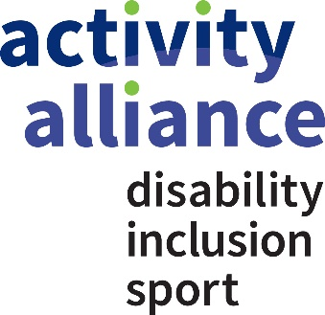

Annex A: Response to brief:

Part 1: Company details
Please complete the table below with details of your company. If you are bidding as a consortium please give the details of the lead bidder.

Registered Company Details:
Company Registration Number:
VAT Registration Number (if applicable):
Main Address:
Main Telephone:
Name of Main Contact:
Email:
Telephone:

Part 2: Response to delivery requirements
Please tell us about your organisation (max. 250 words) Please note this response won’t be marked
Please state what you understand the priority of this brief to be (max. 250 words)
Please outline the approach you propose to take to address the contract delivery requirements specified in section 3 of the brief (max.500 words)
Please share your experience and demonstrate you knowledge and understanding of the physical activity, sport, health and disability sectors (max. 250 words)
Please demonstrate the research experience of the project team (particularly with disabled people, accessibility, and with producing outputs) max 250 words.
Please demonstrate evidence of similar contracts you’ve undertaken (max. 250 words)
Please explain how you will allow for the potential effects of the coronavirus (COVID-19) pandemic on this project (max 250 words)

Part 3: Work packages

Please provide an outline of your proposed work packages and delivery times scales to carry out this contract (please use own template and attach to your response)

Part 4: Schedule of charges

Please complete the table below providing a detailed breakdown of costs against each area (in bold), detailing a total and full ‘Firm Fixed Cost’ for each element of the service provision for the total contract period. You may extend the table to detail additional elements/costs if required.

VAT is chargeable on the services to be provided and this will be taken into account in the overall cost of this contract.

Description of Services
Price
Team member | e.g. John Smith
Rate per day £ | e.g. £400
No of days | e.g. 4 days
Subtotal staff (£ x no of days) | e.g. £1600
Travel and subsistence (provide anticipated breakdown)
Other (Please specify)
Total cost
VAT @ 20%
Total firm contract costs (Including VAT) | £

