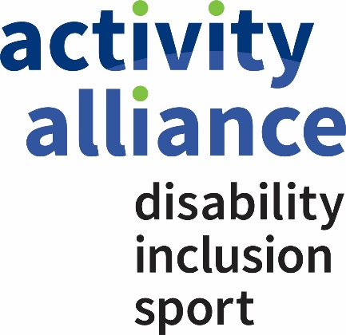

Complaints Policy and Procedure

Aim
Activity Alliance is committed to providing quality services for its stakeholders and working in an open and accountable way that builds the trust and respect of all of them.

One of the ways in which we can continue to do this is by listening and responding to the views of our stakeholders, and in particular by responding positively to complaints.

Therefore we aim to ensure that:
- making a complaint is as easy as possible
- we treat a complaint as a clear expression of dissatisfaction with our service which calls for an immediate response
- we deal with it promptly, politely and, when appropriate, confidentially
- we respond in the right way - for example, with an explanation, or an apology where we have got things wrong, or information on any action taken etc
- we learn from complaints, use them to improve our service, and review annually our complaints policy and procedures.

We recognise that many concerns will be raised informally, and dealt with quickly. Our aims are to:
- resolve informal concerns quickly
- keep matters low-key
- enable mediation between the complainant and the individual to whom the complaint has been referred.

An informal approach is appropriate when it can be achieved. But if concerns cannot be satisfactorily resolved informally, then the formal complaints procedure should be followed.

Scope:
This procedure applies to all staff and Trustees as well as any other stakeholders that come in to contact with Activity Alliance.

Preamble

Definition
Activity Alliance defines a complaint as 'any expression of dissatisfaction (with Activity Alliance, with a member of staff, or with an Activity Alliance Trustee) that relates to Activity Alliance and that requires a formal response'.

Purpose
The formal complaints procedure is intended to ensure that all complaints are handled fairly, consistently and wherever possible resolved to the complainant's satisfaction.

Responsibility
Activity Alliance's responsibility will be to:
- acknowledge the formal complaint in writing;
- respond within a stated period of time;
- deal reasonably and sensitively with the complaint;
- take action where appropriate.

A complainant's responsibility is to:
- bring their complaint, in writing, to Activity Alliance's attention normally within 8 weeks of the issue arising;
- raise concerns promptly and directly with a member of staff in Activity Alliance;
- explain the problem as clearly and as fully as possible, including any action taken to date;
- allow Activity Alliance a reasonable time to deal with the matter;
- recognise that some circumstances may be beyond Activity Alliance's control.

Responsibility for Action: All Staff, and Trustees of Activity Alliance.

Confidentiality
Except in exceptional circumstances, every attempt will be made to ensure that both the complainant and Activity Alliance maintain confidentiality. However the circumstances giving rise to the complaint may be such that it may not be possible to maintain confidentiality (with each complaint judged on its own merit). Should this be the case, the situation will be explained to the complainant.

Monitoring and Reporting
Complaints will be brought to the attention of the Finance, Audit, Risk and Governance Group’s every meeting.

Trustees of Activity Alliance will receive annually an anonymised report of complaints made and their resolution and complaints will be dealt with in accordance with Activity Alliance's Privacy Policy.

Formal Complaints Procedure

Stage 1
In the first instance, if you are unable to resolve the issue informally, you should write to the member of staff who dealt with you, or their manager, so that they have a chance to put things right. If your complaint concerns a Trustee of Activity Alliance, rather than a member of Activity Alliance's staff, you should write formally to the individual concerned. In your letter you should set out the details of your complaint, the consequences for you as a result, and the remedy you are seeking.

You can expect your complaint to be acknowledged within 4 working days of receipt. You should get a response and an explanation within 15 working days.

Our contact details can be found on the Contact Us part of the Activity Alliance Website.

Stage 2
If you are not satisfied with the initial response to the complaint then you can write to Activity Alliance's Chief Executive and ask for your complaint and the response to be reviewed.

You can expect the Chief Executive to acknowledge your request within 4 working days of receipt and a response within 15 workings days.
Activity Alliance's aim is to resolve all matters as quickly as possible. However, inevitably some issues will be more complex and therefore may require longer to be fully investigated.

Consequently timescales given for handling and responding to complaints are indicative. If a matter requires more detailed investigation, you will receive an interim response describing what is being done to deal with the matter, and when a full reply can be expected and from whom.

Final Stage
If you are not satisfied with the subsequent reply from Activity Alliance's Chief Executive, then you have the option of writing to the Chair of the Board of Trustees, stating the reason why you are dissatisfied with the outcome. Our contact details can be found on the Contact Us part of the Activity Alliance Website. You must do this within 10 days of receiving the written response from Activity Alliance's Chief Executive.

The Chair of the Board of Trustees (or their nominee) will respond normally within 10 working days to inform you of the action which will be taken to investigate your complaint, and when you can expect to hear the outcome of the investigation.

Note. If your original complaint was against the Chair of the Board of Trustees, then the final stage will be handled by the Senior Independent Director of Activity Alliance.

Safeguarding
If you have a complaint related to safeguarding at Activity Alliance, please refer to a suite of Safeguarding policies at our website.
Date approved by the Board: 13 September 2023
Date of next review: September 2024

