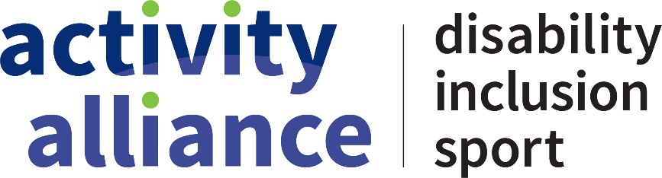

Research charter

Working with people with lived experience of disability, we created a charter that sets out our commitment to barrier-free research.

## We are committed to research that:

* Involves diverse people with lived experience
* Is impactful​ and meaningful
* Is influential ​and leads to change
* Values individuals​

## We are committed to ways of working that:

* Are collaborative and inclusive​
* Happen in spaces that make us all feel safe​
* Honour what you have said​
* Meet your individual needs

## We will communicate with you in a way that:

* Is easy to understand​
* Is accessible for you
* Is suitable for you​

## We are committed to research that ends well. We will:

* Act on what we learn​
* Evaluate the impact of our work
* ​ Tell you what changed as a result of you taking part
* Use your feedback to improve how we do research

## We want people involved in our research to:

* Choose how you get involved
* Be proud of your role​ and know that your work is impactful​
* Feel comfortable, confident and accepted​ as an equal part of our team
* Grow, learn and benefit from taking part​
* Enjoy being part of our research community

For more information on our research or how we work with disabled people, please email [research@activityalliance.org.uk](mailto:research@activityalliance.org.uk)