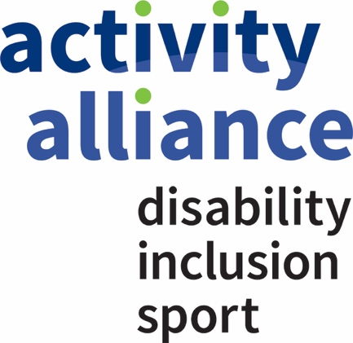



Trustee Recruitment
November 2026

Contents
Welcome to Activity Alliance 3
How we create change? 4
A trusted voice. A powerful alliance. 4
Our ambition and your opportunity. 5
As a Trustee, you will help us: 6
Diversity and inclusion statement 6
Board role and duties 7
Additional information 8
How to apply 9
Privacy notice 10

Welcome to Activity Alliance

Sport should belong to everyone. But right now, it does not. Across England, disabled people face barriers that most non-disabled people never have to consider. Activity Alliance is the national charity and leading voice for disabled people in sports and activities. For almost 30 years, we have turned lived experience, trusted research, and practical expertise into action, challenging exclusion and helping organisations make inclusion happen.

This is an exciting moment to join our Board. Our strategy, We all belong, sets out a clear ambition: a future where every disabled person feels they belong in sports and activities. As a Trustee, you will help turn that ambition into lasting change, bringing your expertise and lived experience to a committed Board and an exceptional team.

We are recruiting three new Trustees: two appointed by the Board and one appointed by our Members. If you share our determination to make inclusion the expectation, not the exception, we would be delighted to hear from you.

Why this matters

Disabled people are twice as likely to be inactive as non-disabled people - even though more than four in five want to be more active. We call this the National Activity Gap. It limits choice, health, independence and connection, and it costs society £11 billion every year in lost social value. The cost to individuals is greater still.

Closing this gap is not a niche sporting issue. It is central to a healthier, fairer and more prosperous country. When disabled people are supported to meet the Chief Medical Officers’ activity guidelines, their activity delivers £6,200 in social value per person, every year. That’s three to four times the value generated by non-disabled people being active.

The case for change at a glance
2×  Disabled people are twice as likely to be inactive as non-disabled people. | £11 billion  The social value lost every year because disabled people face barriers to being active. | £6,200  Social value delivered per disabled person, per year, when supported to meet CMO activity guidelines.
Inclusion is not an optional extra. It is how we unlock better health, stronger communities and greater national prosperity.

How we create change?

We work with and for disabled people, alongside an alliance of partners, to improve opportunities to be active. We turn lived experience and trusted evidence into practical action:
- We influence: pushing for inclusion to sit at the heart of policy, investment and plans across sports and activities.
- We equip: giving local and national organisations the evidence, guidance and tools to make inclusion real.
- We deliver: designing and leading national and regional programmes that widen access, choice and opportunity.
- We prove what works: producing trusted research, including the Annual Disability and Activity Survey, to shape policy and practice.

A trusted voice. A powerful alliance.

Activity Alliance is the go-to organisation for insight, evidence and comment on disabled people’s experiences in sports and activities. Our Members, including National Disability Sport Organisations and regional partners, are an important part of our governance. We also work across sport, leisure, health, education, local government and business to build a wider movement for change.

Launched in December 2025, our Supporter Scheme has already brought together almost 600 people from more than 400 organisations - a powerful sign of the growing movement for change behind our mission.

Programmes such as Get Out Get Active and Include to Improve show what is possible when local people, communities and organisations work together. Sustainable, social and enjoyable ways for more people to be active.

Our long-term partnership with Sport England and our five-year systemic investment reflect the strength of our reputation and the confidence in our work.

Adam Paker became Chair of the organisation in October 2025, bringing more than 25 years of leadership experience from across the sport and physical activity sector. His career has included senior commercial roles at FIFA and Chief Executive positions at Commonwealth Games England and Swim England, where he successfully led significant organisational growth and transformation.

Adam is a passionate advocate for the power of sport and activity to change lives. As Chair, he is committed to helping build a future where disabled people feel welcomed, valued and able to participate fully in sport and physical activity, ensuring everyone has the opportunity to experience the benefits of being active.

Adam Blaze joined as Chief Executive in January 2023. Having previously held senior roles at Sport England, he brings a strong track record of strategic leadership, partnership building and turning insight into meaningful action. Driven by a commitment to creating lasting change, Adam leads the organisation with ambition, energy and a clear focus on improving opportunities and outcomes for disabled people through sport and activity.
Together, they provide a powerful combination of governance, strategic expertise and sector influence, guiding the organisation through its next phase of growth and impact. For prospective trustees, this is an opportunity to join an engaged and ambitious Board, working alongside leaders who are committed to creating a more inclusive future for disabled people.

Our ambition and your opportunity.

Our strategy focuses on three ambitions:
- Sports and activities meet disabled people’s needs- so more people can access and feel the benefits of taking part.
- Disabled people influence campaigning, policy and decisions- so lived experience drives change.
- Inequalities are tackled through collective action- so partnerships create greater impact together.

We cannot close the National Activity Gap alone- and that is where your leadership matters. We are building a powerful circle of disabled people, partners, policymakers, funders and businesses to close this gap. Our Trustees will help us grow that movement, hold us to our purpose and make bold, well-governed choices that deliver lasting change.

As a Trustee, you will help us:

- Keep disabled people’s voices at the centre of our strategy, campaigning and decisions.
- Make inclusion the expectation across sport, leisure, health, workplaces and communities.
- Influence national change - from protecting benefits and equipping health and care workers to increasing accessible outdoor spaces.
- Build the movement by inspiring partners, funders and businesses to invest, collaborate and act.
Bring your experience. Challenge our thinking. Help ensure that every disabled person can be active, in the way they choose.
If you believe sport should belong to everyone, this is your opportunity to help lead the change.

Diversity and inclusion statement

Activity Alliance is committed to being an organisation where people feel they belong and a place they can thrive in. This is regardless of your background or personal circumstance.

We are proud to be an equitable employer and partner. We expect the same from our partners and colleagues, right across the board and staff team.

We want to be a safe, welcoming, considerate, and responsible workplace. We value diversity as a strength, and we are better with greater equality and inclusion. Our ambitious vision is embedded in our governance, values, and staff development. The people who we work for and with make us a reputable organisation to know and trust. Nobody should miss opportunities or feel they do not belong at Activity Alliance.

We take proactive steps to create an inclusive environment for everyone who works for or with us. We promote equality and diversity so that everyone feels welcome, with particular regard to the protected characteristics set out in the Equality Act 2010: age, disability, ethnicity (including race, colour and nationality), gender, gender reassignment, religion or belief, sexual orientation, marriage and civil partnership, pregnancy and maternity.

This statement applies to all staff, beneficiaries, trustees, volunteers, and our partners.
You can read more about our work related to equity, diversity and inclusion on our website.

Board role and duties

Being part of the Activity Alliance Board is rewarding for many reasons - from making a difference to gaining new experiences and relationships. It will also sometimes be demanding of your time, skills, and knowledge. Being aware of the expected duties and responsibilities as a Director on a Board of a charity will help you to play your role effectively. This not only serves Activity Alliance well but also gives you confidence that you will comply with key legal requirements.

As a Trustee you will:
- have an outstanding commitment to Activity Alliance with a strong understanding of the organisation’s values as well as of the Nolan Seven Principles of Public Life.
- be willing to devote the necessary time and energy.
- possess a strategic vision and independent judgement.
- understand and accept the legal duties, responsibilities, and liabilities of trusteeship.
- be able to work effectively as a team member and to make decisions for the organisation's good.
- have a good, independent judgement and a willingness to be open and speak your mind.

as well as

- contribute actively to the Board of Trustees' role in giving strategic direction to the organisation, setting overall policy, defining goals, setting targets, and evaluating performance against agreed targets.
- ensure that the organisation complies with its governing documents, charity law, company law and any other relevant legislation or regulations.
- safeguard the reputation and values of the organisation.
- represent the organisation at functions and meetings when appropriate, and act as an ambassador for Activity Alliance.

Currently, we are particularly interested in recruiting Trustees with understanding, skills, and/or experience in one or more of the following areas:
- Safeguarding children and vulnerable adults in sport
- Working in communities
- Governance and risk in the charity sector.

Some of our Trustees have previous experience of giving support to or membership of non-executive boards, but not all. We welcome applications from people who are considering this as their first experience in taking on Board responsibilities and will provide support and training to those taking this opportunity.

Additional information

Eligibility

Under the Charities Act 2011, you are unable to serve as one of our Trustees if:
- You are under the age of sixteen.
- You are an undischarged bankrupt or are otherwise disqualified by law from serving as a company director.
- A person who has an unspent conviction involving dishonesty or deception or who is otherwise disqualified by law from serving as a charity trustee.

The commitment

The Board meets at least four times per year – in person, at Sport Park in Loughborough or London, and virtually. The meetings take place mid-week, during working hours. When added to other ad hoc responsibilities, we anticipate the time commitment to be at least 8 days a year.

Attendance at the Annual General Meeting is required from the Chair, chairs of sub-groups and Member-Nominated Trustees.

We strive for full accessibility when it comes to facilitating meetings, events, or webinars etc. This would include accessible event venues, hotels, accessible formats etc.

Conflicts of interest

All candidates will be asked to declare any conflicts of interest.

Terms of appointment

The posts are for an initial term of up to three years, which may be extended for two further terms of three years.

Remuneration

The positions are unpaid, although we reimburse travel costs and other direct expenses incurred.

Benefits

All Trustees receive Safeguarding and Trustee training upon joining. We also provide other training on a needs basis.
Trustees are provided with charity apparel.

Sub-groups

All trustees are expected to serve on one of our committees, which meet outside the main board schedule, at times most suitable for them.
Attending events or acting as a representative
All trustees are encouraged to attend the events we organise. This could include staff away days, online events or webinars that promote our work, or attending the sport events we deliver. We may also ask you to represent Activity Alliance at networking events or may ask you to act as a spokesperson.

How to apply

If you would like to apply, please supply the following to jobs@activityalliance.org.uk by no later than 9am on 4 January 2027:
- A detailed CV setting out your career history, with responsibilities and achievements.
- A covering letter (maximum two sides) highlighting your suitability for the role and how you meet the person specification. Please note that the covering letter is an important part of your application and will be assessed as part of your full application.
- Alternatively, you may provide a video, audio file, or presentation.

Please provide details of two professional referees together with a brief statement of their relationship to you and over what period of time they have known you. Referees will not be contacted without your prior consent.

If you have any questions or would like to arrange a call to discuss the role, please email jobs@activityalliance.org.uk

After reviewing all the applications received by the closing date, we will invite some applicants to join us for an online conversation. We will then (with your agreement) follow up on references you have given us before making a final decision on who to invite to join us as Trustees.

For more information on Activity Alliance, please visit activityalliance.org.uk

Privacy notice

At Activity Alliance, we want to make sure all the personal details we hold about you are safe and secure, so we want you to know as much as possible about what we do with your personal information.
This privacy notice applies to everyone who interacts with us in any way unless the reason you do so is already covered by another of our privacy notice(s) available at www.activityalliance.org.uk/privacy.
So, for example, this privacy notice will not apply if you are one of our current or former staff or you are participating, volunteering and/or peer mentoring in one of our events. Our privacy notice in relation to our events can be found at www.activityalliance.org.uk/privacy. Please also read this notice to the extent it applies to your activities, as it may apply to you in addition to this privacy notice.
This privacy notice will cover you if you interact with us for any other reason. For example, this privacy notice will cover someone who:
- is going through a recruitment process to come to work for us,
- uses our website,
- attends one of our events or training courses,
- works at a customer or supplier of ours or another organisation that we deal with (such as one of our members or funding partners),
- or anyone else who is affected by our activities to the extent not covered by another of our privacy notices.

This privacy notice covers a wide range of individuals and different types of relationships and interactions with us. As such, not all aspects of this privacy notice may apply to you depending upon the nature of your relationship and interactions with us. If you are unsure, then you can always ask us by contacting us at info@activityalliance.org.uk or call 08081 756991.

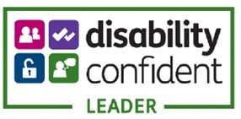

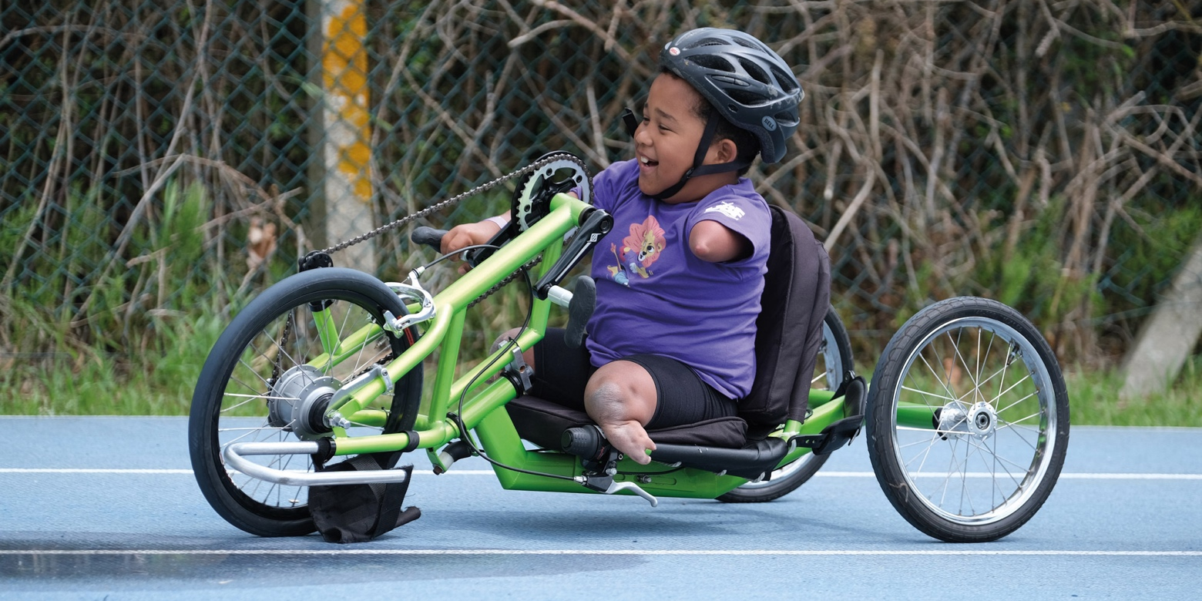

 | 0808 175 6991
 | info@activityalliance.org.uk
 | activityalliance.org.uk
 | ActivityAlliance
 | @AllForActivity

